PANDEMIC PREPAREDNESS PLAN
DEVIKULANGARA LSGI

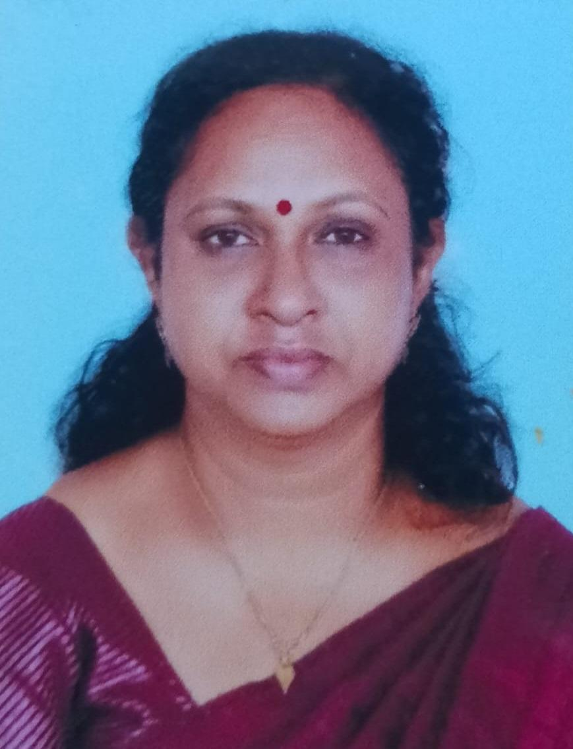
MESSAGE FROM PRESIDENT LSGI

It gives me immense pleasure to present the Pandemic Preparedness Plan 2026 of the Family Health Centre, Devikulangara. The experiences of recent global health emergencies have clearly reminded us that preparedness, coordination, and community participation are the strongest pillars in safeguarding public health.
As a Grama Panchayat, we are committed to strengthening our primary healthcare system and ensuring that our community is well-equipped to prevent, detect, and respond effectively to any future public health threats. This Pandemic Preparedness Plan reflects our collective responsibility to protect the health and well-being of every resident of Devikulangara.
I appreciate the dedicated efforts of the medical officers, Health Inspectors, Public health Nurses, ASHA workers & other staff, ward members, and all frontline health workers who have contributed to the development of this comprehensive plan. Their tireless service and commitment form the backbone of our health system.
The Panchayat assures full support in terms of coordination, resource mobilization, awareness campaigns, and interdepartmental collaboration to successfully implement this plan. Together, with community participation and proactive measures, we can build a resilient and healthier Devikulangara.
Let us remain vigilant, prepared, and united in our efforts to safeguard public health.
With best wishes,
Ambilikala T.
President
GramAPanchayat, Devikulangara
05-02-2026

MESSAGE FROM HEALTH STANDING COMMITTEE CHAIR
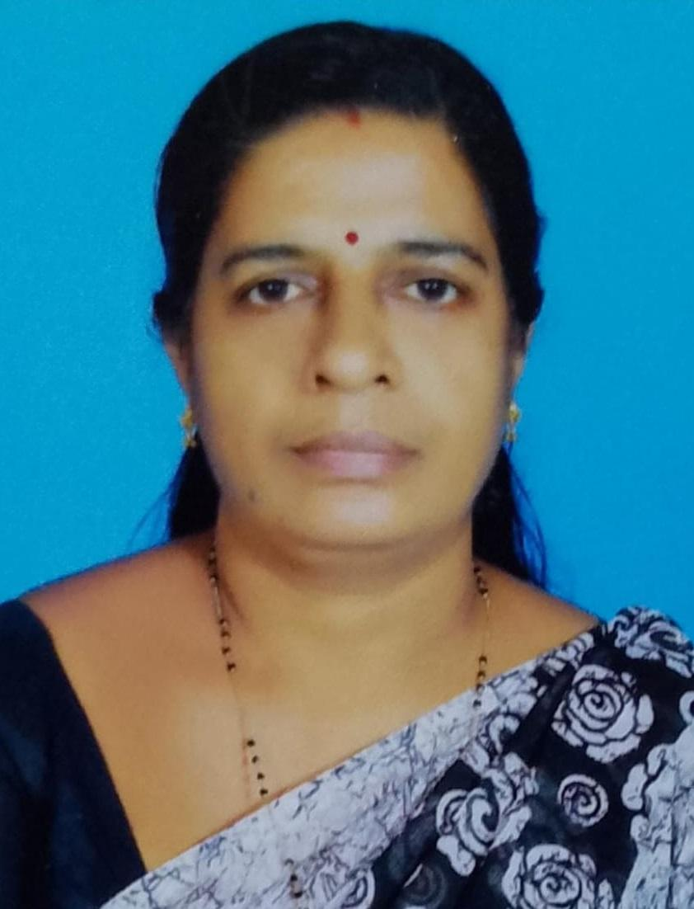

The health and safety of our community remain our highest priority. The Pandemic Preparedness Plan 2026 of the Family Health Centre, Devikulangara, is a significant step towards strengthening our capacity to effectively prevent, identify, and respond to any future public health emergencies.
The recent global health crises have taught us the importance of preparedness, timely intervention, and coordinated action. This plan reflects a proactive and systematic approach to ensure surveillance, early detection, resource management, community awareness, and efficient response mechanisms at the grassroots level.
As Chairperson of the Health Standing Committee, I assure continuous support in monitoring implementation, strengthening public health infrastructure, and promoting community participation. Our frontline health workers, including medical officers, nurses, health inspectors Public health Nurses , ASHA workers, and volunteers, play a crucial role in safeguarding our community, and their dedication is deeply appreciated.
Through collective effort, responsible leadership, and active public cooperation, we can build a resilient healthcare system capable of meeting future challenges with confidence.
Let us move forward with commitment and preparedness for a healthier Devikulangara.
With sincere regards,
Bindhu
HealtStandingCommittee Chairperson
Grama Panchayat, Devikulangara
05-02-2026

MESSAGE BY MEDICAL OFFICER
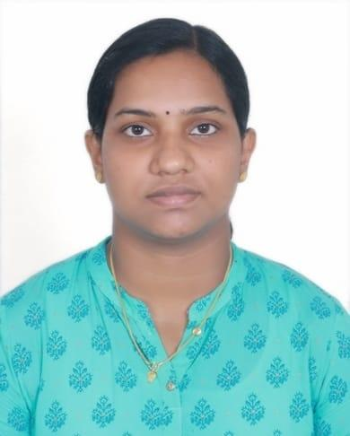

It is my honour to present the Pandemic Preparedness Plan 2026 for the Family Health Centre, Devikulangara. The past global health crises have taught us valuable lessons on the importance of early preparedness, strong surveillance, and effective community engagement in safeguarding public health. Pandemic preparedness is not just a plan on paper, it is a commitment to protecting every individual in our community through coordinated prevention, rapid detection, timely response, and resilient health services.
This plan has been developed with a focus on strengthening our healthcare functions at the grassroots level, ensuring readiness for any future outbreak or health emergency. It emphasizes enhanced surveillance, efficient case management, infection control measures, and community awareness all critical components for effective pandemic response. Preparedness also includes building capacity among health workers through training, conducting mock drills, and ensuring availability of essential supplies and resources.
I thank the entire team of healthcare professionals, frontline workers, and support staff for their dedication and tireless efforts. I also extend my sincere appreciation to the Panchayat authorities, Health Standing Committee, ASHA workers, and volunteers whose cooperation has been vital in framing this plan.
Let us continue to work together with vigilance, compassion, and responsibility to build a healthier, safer, and more resilient Devikulangara, prepared for any public health challenge that lies ahead.
With best regards,
Dr Anoopa
Medical Officer
Family Health Centre, Devikulangara
03-02-2026

Executive Summary

The Pandemic Preparedness Plan of Devikulangara is a strategic framework developed to strengthen the readiness of the health system and allied sectors to effectively respond to public health emergencies. The primary purpose of this document is to establish a clear, practical, and coordinated approach for preventing, detecting, and responding to pandemics and other large-scale disease outbreaks.
This plan serves as a baseline for rapid mobilization during a health emergency. In times of crisis, delays in decision-making and resource allocation can significantly impact public health outcomes. By clearly defining roles, responsibilities, communication channels, and standard operating procedures, this document ensures that all stakeholders can act promptly and efficiently. It outlines mechanisms for surveillance, reporting, case management, infection prevention and control, logistics management, and risk communication. Having these systems predefined allows for immediate activation without confusion or duplication of efforts.
Another key purpose of this document is to identify gaps in resources and high-risk populations within Devikulangara. Through systematic assessment, the plan evaluates existing healthcare infrastructure, human resources, medical supplies, emergency transport systems, isolation facilities, and laboratory support. Identifying shortages or vulnerabilities in advance enables authorities to take corrective action before an emergency arises. The plan also maps vulnerable groups such as the elderly, persons with chronic illnesses, pregnant women, children, migrant workers, economically disadvantaged families, and persons with disabilities. Recognizing these high-risk populations helps in prioritizing preventive measures, vaccination drives, targeted awareness campaigns, and timely medical interventions.
The document further aims to ensure coordinated action between Government, Private, and AYUSH sectors. Effective pandemic response requires multi-sectoral collaboration. The Government health system, private hospitals and clinics, laboratories, pharmacies, traditional medicine practitioners (AYUSH), local self-government institutions, educational institutions, and community-based organizations must work together. This plan establishes a framework for interdepartmental convergence, data sharing, joint training, resource pooling, and unified communication strategies. Such coordination avoids fragmentation of services and strengthens overall response capacity.
In addition, the plan emphasizes community participation and risk communication. Transparent and timely dissemination of accurate information reduces panic, prevents misinformation, and encourages responsible health-seeking behaviour. Community volunteers, ASHA workers, Kudumbashree members, and local leaders play a crucial role in strengthening grassroots-level response mechanisms.
Overall, this Pandemic Preparedness Plan is not only a response document but also a resilience-building tool. It aims to safeguard public health, maintain essential services, and minimize social and economic disruption during future health emergencies.

EXECUTIVE SUMMARY
The Pandemic Preparedness Plan for Cheppad Family Health Centre has been developed to strengthen the capacity of the local health system to effectively prevent, detect, and respond to public health emergencies. Cheppad Grama Panchayat, with its unique geographical features such as low-lying areas, backwaters, and flood-prone regions, faces increased vulnerability to infectious disease outbreaks and environmental health risks. The presence of diverse population groups, including the elderly, children, and migrant workers, further necessitates a comprehensive and inclusive approach to health emergency preparedness.
This plan outlines key strategies focused on strengthening disease surveillance, early warning systems, and rapid response mechanisms at the community level. It emphasizes the importance of intersectoral coordination involving the Local Self Government Department (LSGD), health institutions, and community stakeholders such as ASHA workers and Anganwadi staff. Ensuring the continuity of essential health services during emergencies, protecting vulnerable populations, and enhancing risk communication and community awareness are central components of the preparedness framework.
The document also highlights the need for capacity building, resource mapping, and infrastructure strengthening to improve resilience against future pandemics and disasters. Lessons learned from past experiences, including floods and the COVID-19 pandemic, have been incorporated to address existing gaps and improve response efficiency. Through a collaborative and proactive approach, the plan aims to build a resilient, responsive, and sustainable health system that can safeguard the well-being of the Cheppad community in the face of evolving public health challenges

LIST OF ABBREVIATIONS

LSGD/LSGI | Local Self Government Department / Local Self Government Institution
BMO | Block Medical Officer
IDSP | Integrated Disease Surveillance Programme
NDMA | National Disaster Management Authority
PPE | Personal Protective Equipment
ICMR | Indian Council of Medical Research
CD | Communicable Diseases
nCD | non Communicable Diseases
FHC | FAMILY HEALTH CENTRE
HWC | HEALTH & WELLNESS CENTRE
HI | HEALTH INSPECTOR
JHI | JUNIOR HEALTH INSPECTOR
PHN | PUBLIC HEALTH NURSE
JPHN | JUNIOR PUBLIC HEALTH NURSE

TABLE OF CONTENTS

INTRODUCTION 9
LSGD AT A GLANCE 11
ADMINISTRATIVE BOUNDARIES OF DEVIKULANGARA PANCHAYAT 11
INTEGRATED HEALTH INFRASTRUCTURE MAP OF DEVIKULANGARA PANCHAYAT 12
AUXILIARY INFRASTRUCTURE & LOGISTICAL RESOURCE MAP OF DEVIKULANGARA PANCHAYAT 13
LSGD ONE HEALTH INFRASTRUCTURE 14
GENERAL PROFILE OF THE LSGI’S 15
Background of the LSGI 15
Demographic and Vulnerable Population 16
Clinical Vulnerability 17
INFRASTRUCTURE & RESOURCE INVENTORY 20
Health Facility Directory & Basic Capacity in the LSGD 20
Private Clinics 21
Healthcare Education & Training Institutions 22
Specialized Services & Emergency Inventory 22
Oxygen & Diagnostic Capacity 24
Diagnostics Summary 25
Laboratory Identification & Basic Details 26
Social and Community Infrastructure for Emergency Use 26
Human resources 28
Community & Support Cadre 29
Community Organizations 30
Administrative & Emergency Services 30
Information regarding resources 32
ONE HEALTH & ENVIRONMENTAL SURVEILLANCE 33
Animal & Bird Population 33
Veterinary Infrastructure 35
Veterinary Doctors & Workforce 36
High-Risk Interface Points (Surveillance Sites) 37
Environmental Risk Mapping 38
Disease Seasonality Mapping 39
Vulnerability Mapping 40
EPIDEMIOLOGICAL TRENDS (2021–2025) 42
Disease Burden among human beings(Last 5 Years) 42
*(use the above table data to create the graph/diagram) 43
Seasonal Trend Analysis 44
Outcome Based Trend Analysis- 2025 50
Transmission Trend 52
Integrated Disease Hotspot Map (2021–2025) 53
Preparedness and Response Protocol at LSG Level 55
Constitution of One Health Committee 55
Pandemic Response Workforce 56
Activities and Measures before and during Pandemic 58
PHASE 1 - Alert / Preparation 58
PHASE 2 - Active Response 63
Standard Screening Protocol 64
PHASE 3 - Surge Capacity 75
Conversion of Community Facilities 76
CONCLUSION 77
RECOMMENDATIONS 78
ANNEXURE - 1 79
IMPORTANT PHONE NUMBERS 79

INTRODUCTION
- Devikulangara Grama Panchayat, situated in Alappuzha district of Kerala, is a coastal local self-government area known for its unique geographical features, including low-lying lands, backwaters, and proximity to the Arabian Sea. The region’s landscape plays a vital role in shaping the climate, economy, and living conditions of the population. However, these features also make the Panchayat vulnerable to seasonal flooding, waterlogging, and environmental health challenges, particularly during the monsoon season.
- The Panchayat is home to a diverse and densely distributed population engaged in various occupations such as fishing, agriculture, coir production, and small-scale businesses. In recent years, there has been a shift towards service sector employment and migration, contributing to changing socio-economic dynamics. The presence of vulnerable groups, including the elderly, children, and migrant workers, highlights the importance of inclusive development and effective delivery of public services at the grassroots level.
- Devikulangara has an active Local Self Government system that plays a crucial role in implementing developmental programmes, public health initiatives, and welfare schemes. Strong coordination between the Panchayat, health institutions, and community-level workers such as ASHAs and Anganwadi staff ensures better outreach and service delivery. In the context of emerging health challenges and disaster risks, the Panchayat continues to focus on strengthening infrastructure, enhancing preparedness, and promoting community participation to ensure sustainable and resilient development.

​

LSGD AT A GLANCE

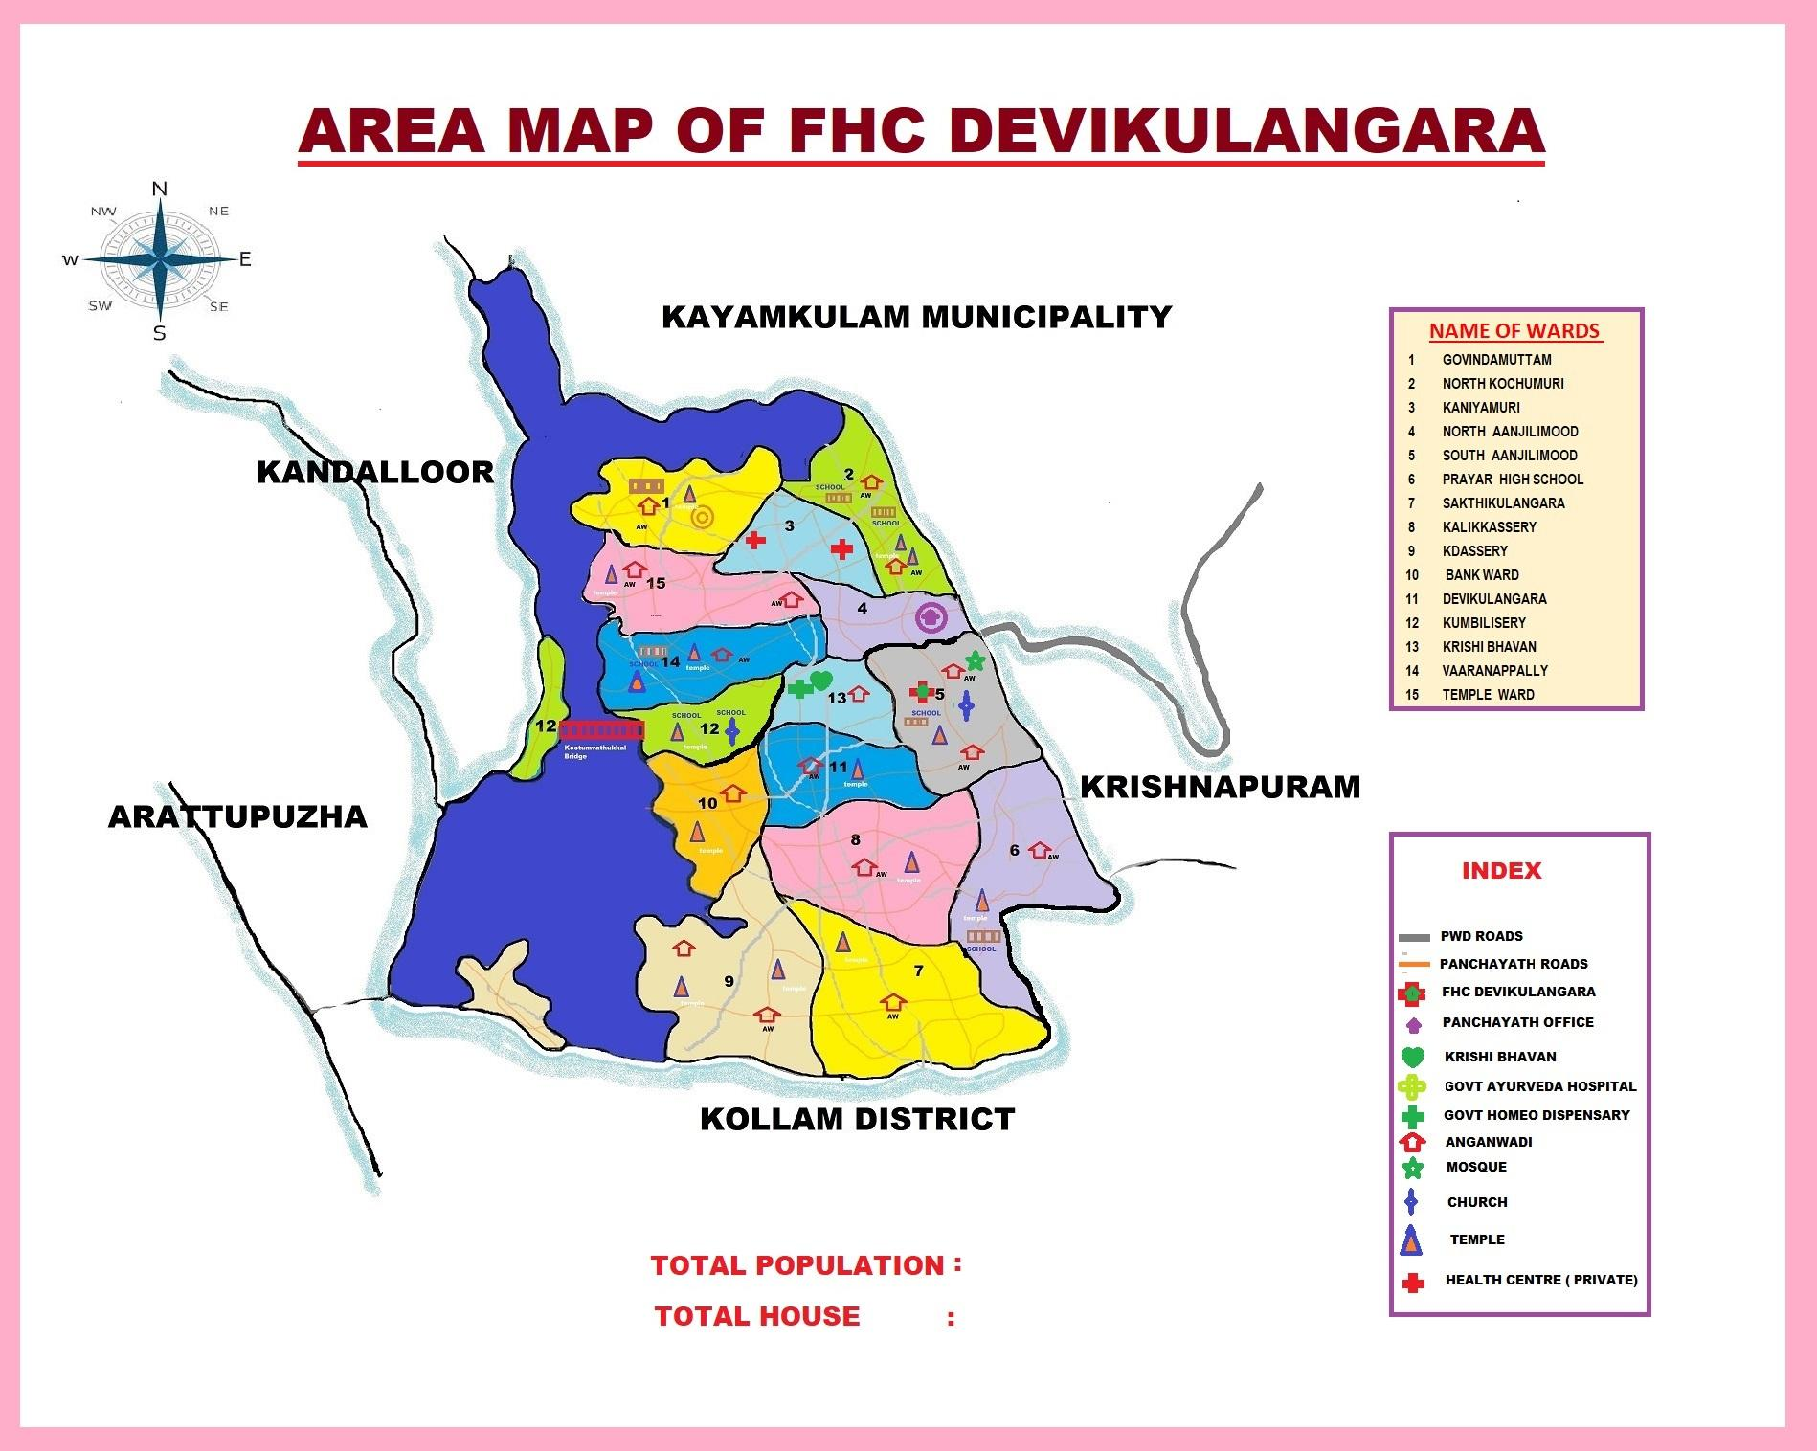

INTEGRATED HEALTH INFRASTRUCTURE MAP OF DEVIKULANGARA PANCHAYAT

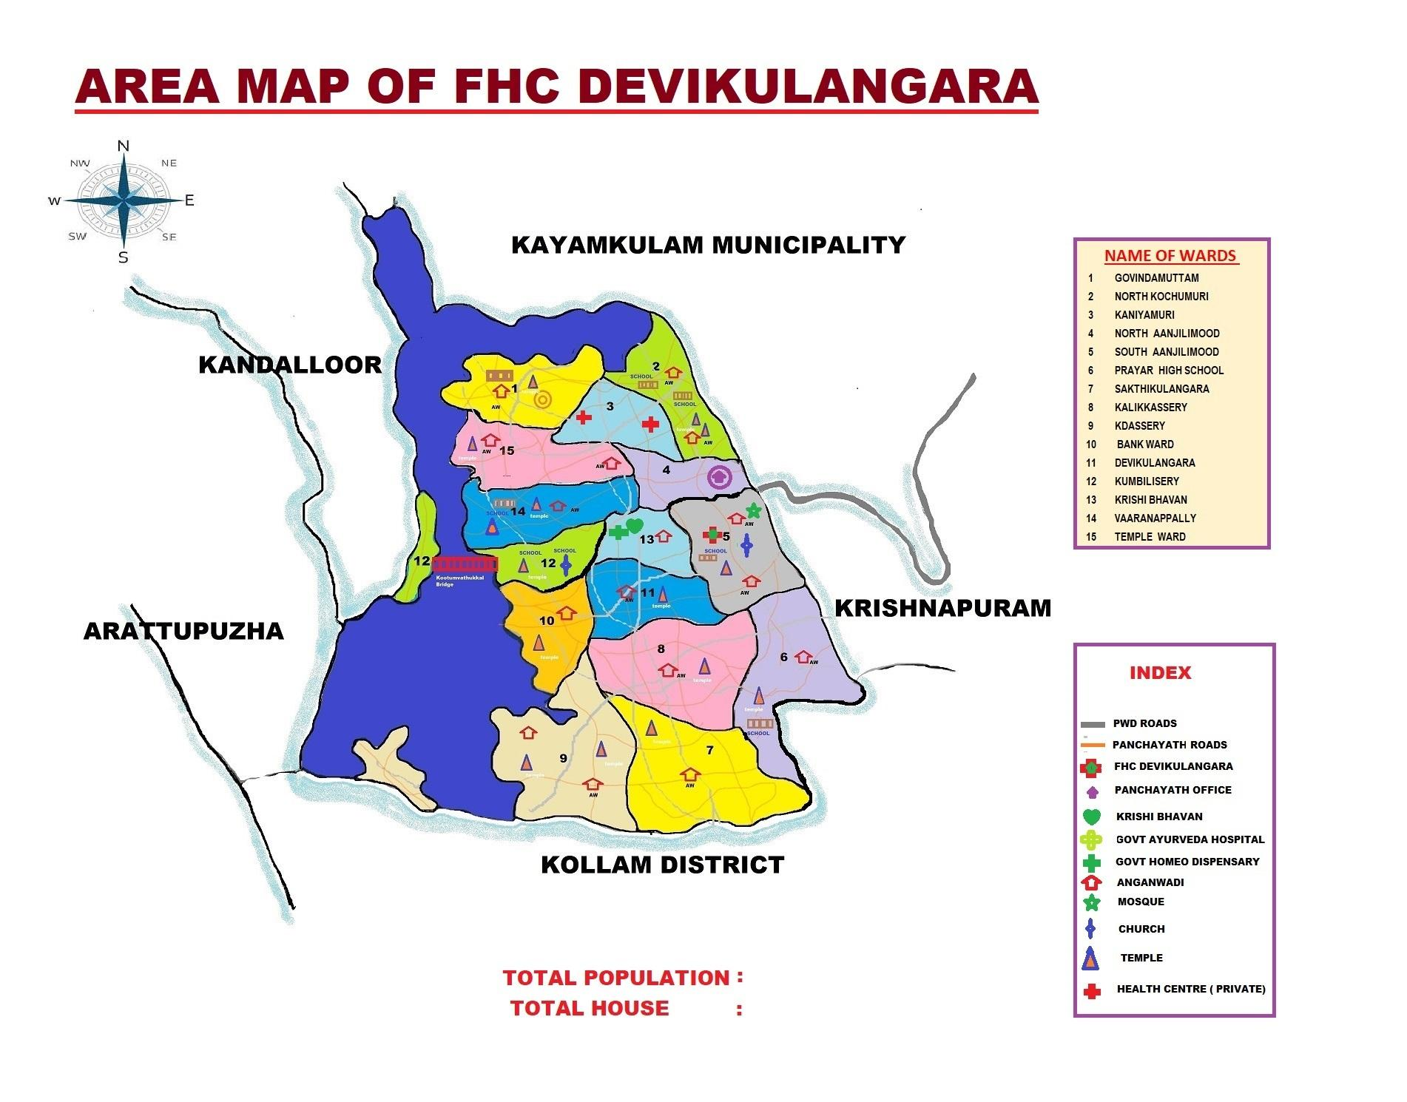

AUXILIARY INFRASTRUCTURE & LOGISTICAL RESOURCE MAP OF DEVIKULANGARA PANCHAYAT

GOVERNMENT ,PRIVATE HOSPITALS AND CLINICS

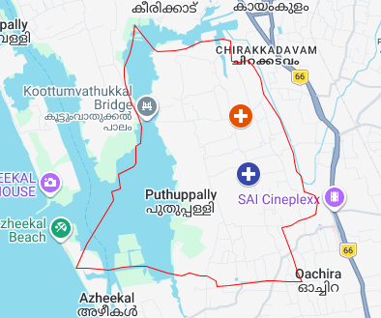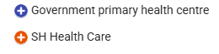

SCHOOLS LOCATED IN DEVIKULANGARA PANACHAYATH

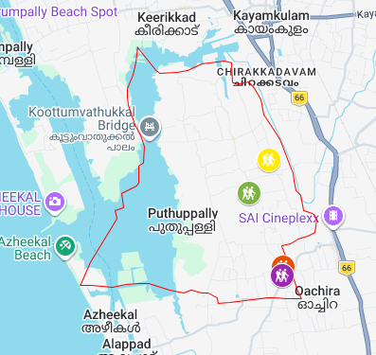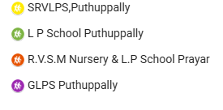

COMMUNITY HALLS AND GOVERNMENT OFFICES IN DEVIKULANGARA

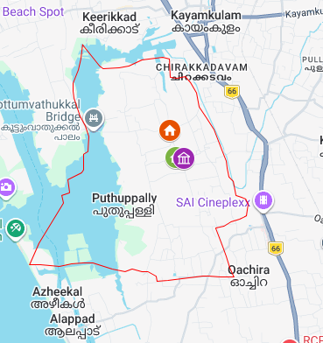

GENERAL PROFILE OF THE LSGI’S

Background of the LSGI

Devikulangara Grama Panchayat, located in Alappuzha district of Kerala, is a coastal Local Self Government institution characterized by a mix of low-lying lands, water bodies, and densely populated residential areas. The geographical setting, with its proximity to backwaters and the sea, plays a significant role in shaping the local environment and livelihoods. Seasonal variations, especially during the monsoon, often lead to waterlogging and increased risk of flooding, which in turn influence sanitation conditions and the spread of communicable diseases.
The Panchayat is administratively divided into multiple wards and supports a diverse population engaged in fishing, agriculture, coir industry, and other informal sectors. Over time, there has been a noticeable shift in socio-economic patterns, including increased migration and dependence on service sector jobs. The presence of vulnerable groups such as elderly individuals, women, children, and migrant workers necessitates inclusive and well-planned service delivery systems. The Local Self Government plays a crucial role in coordinating development activities, welfare schemes, and essential services at the grassroots level.
From a public health perspective, Devikulangara faces multiple challenges related to environmental and seasonal risks, including vector-borne, water-borne, and zoonotic diseases. Experiences from past events such as floods and the COVID-19 pandemic have exposed gaps in preparedness, infrastructure, and rapid response mechanisms. These challenges underline the importance of strengthening local governance through better planning, intersectoral coordination, and community participation to ensure resilience and effective management of public health emergencies.

Table 1: Background of LSGD
Item | Details
Name of LSGI | DEVIKULANGARA
Type (GP/Municipality etc.) | GRAMA  PANCHAYATH
Block | MUTHUKULAM
District | ALAPPUZHA
Number of wards | 15
Total area (sq. km) | 7.07 sq km
Population (latest) | 24476
Population density | 760 persons/sq km
Terrain (coastal/low-lying/backwaters/foothills, etc.) | midland/central planes
Number of rivers passing through LSGI | 1
Number of ponds in the LSGI | 17
Number of wells in LSGI | 4682

Demographic and Vulnerable Population
Understanding the demographic composition and vulnerable population groups is essential for pandemic preparedness. Children, elderly, economically deprived families, migrant workers, and socially vulnerable groups are at increased risk during public health emergencies due to higher exposure, limited access to services, and dependency on public systems.

Item |  | Details in numbers
DEMOGRAPHIC PROFILE
Total population |  | 24476
Male |  | 10247
Female |  | 11028
Transgender |  | 0
Children under 5 |  | 729
Adolescent |  | 1870
Elderly (>60) |  | 3954
SOCIAL/LIVELIHOOD VULNERABILITY
EPEP family |  | 26
BPL family |  | 2989
Tribal communities |  | 0
Migration | Immigrant | 201
 | Emigrant | 1130
Socio-economically deprived |  | 26
Fisherfolk |  | 39
Graphs: Population pyramid if possible for seeing if your LSGI has a high "dependency ratio" (lots of children and elderly compared to working adults).

Clinical Vulnerability
Certain population groups need priority healthcare & are at higher risk of severe illness, complications, and mortality during pandemics. Patients with chronic diseases, those requiring regular medical care, and individuals with mobility or functional limitations face challenges in accessing timely care during emergencies. Mapping these groups helps in prioritizing continuity of treatment, medicine stock planning, oxygen support, referral transport, and targeted home-based care.
Item | Details in numbers
Pregnant women | 72
Lactating mothers | 195
Bedbound patients | 132
Patients under palliative care other than bedbound | 152
Patients on Haemodialysis | 9
Patients on CAPD | 3
Cancer patients | 149
Haemophilic patients | 0
Mentally challenged | 76
Differently abled | 226
Diabetic patients | 917
Hypertensive patients | 1827
TB patients | 4

Graphs: Bar chart for vulnerable groups
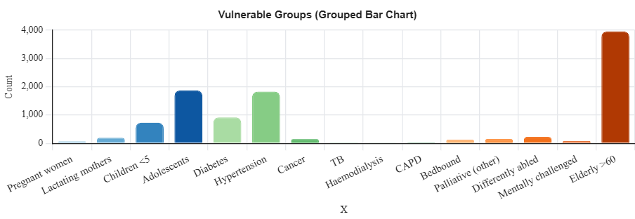
Clinical Vulnerability Profile by Category
Categorization of clinical vulnerability supports prioritized planning for medicine supply, oxygen support, referral transport, and home-based care for high-risk populations during emergencies.

Group | Conditions | Total | Percentage (%)
Maternal | Pregnant women, Lactating mothers | 267 | 1.09%
Chronic Illnesses | Diabetes, Hypertension, TB, Cancer, Dialysis, CAPD | 2909 | 11.88%
Mobility / Functional limitation | Bedbound, Palliative (non-bedbound), Mentally challenged, Differently abled | 586
Overall Total |  | 3762 | 15.37%  of (Population)

Major Festivals

Major festivals in Devikulangar, such as the Festival Season of Temples ,Onam , Pongala, etc., are high-risk periods for the transmission of communicable diseases due to overcrowding and increased population movement. During the season, planning and preparedness for outbreak prevention is a challenge for the health system, mainly because of the difficulty of monitoring and controlling the overcrowding. Overcrowding often results in limited space, inadequate sanitation, and difficulty in ensuring proper health protocols.Moreover, the movement of people from various states increases the transmission of infectious diseases across districts. To reduce these risks, the intersectoral coordination of all other departments is crucial for timely prevention and response.

Sl. No. | Name of festivals | Month | Key Public Health Risk
1 | DEVIKULANGRA TEMPLE | MARCH | Over crowd
2 | SAKTHIKULANGARA TEMPLE | MARCH | Over crowd
3 | KALEELASSERIL TEMPLE | FEBRUARY | Over crowd
4 | VARANAPPALLY TEMPLE | FEBRUARY | Over crowd
5 | SATHA NADA TEMPLE | MARCH | Over crowd
6 | SASTHANADA TEMPLE | FEBRUARY | Over crowd

INFRASTRUCTURE & RESOURCE INVENTORY

Health Facility Directory & Basic Capacity in the LSGD
This section provides an overview of the healthcare infrastructure available within the LSGD area. It outlines the distribution and basic capacity of health facilities that form the backbone of service delivery during routine times as well as public health emergencies.

Family Health Centres (FHCs) and Community Health Centres (CHCs) generally function as the first point of contact for the community, providing essential outpatient and inpatient services. General Hospitals (GH) and Medical College Hospitals (MCH), where accessible, serve as the main referral centres for advanced diagnostics, specialist care, and critical services during public health emergencies. This inventory helps identify existing strengths, gaps, and potential surge capacity that can be mobilised during a pandemic or disaster.

Table 5. Health Facility Resource Summary
Sl.no. | Health Facility | Type of Facility (MCH/GH/CHC/FHC/SC etc.) | Contact Number | Total beds | ICU Beds | Oxygen-Supported Beds | No. of Ventilator Support | No. of ambulances
Government Healthcare Facilities
1 | FHC DEVIKULANAGRA | FHC | 0476-2698686 | 0 | 0 | 0 | 0 | 0
2 | HWC MAIN CENTRE | SC | 0476-2698686 | 0 | 0 | 0 | 0 | 0
3 | PRAYAR NORTH | SC | 0476-2698686 | 0 | 0 | 0 | 0 | 0
4 | PUTHUPPALLY NORTH | SC | 0476-2698686 | 0 | 0 | 0 | 0 | 0
Private Healthcare Facilities
1 | SH HOSPITAL | HOSPITAL | 9747512277 | 6 | 0 | 0 | 0 | 0
AYUSH Healthcare Facilities
1 | GOVT;AYURVEDA DISPENSORY | 0 | 9567432390 | 0 | 0 | 0 | 0 | 0
2 | GOVTT HOMEO DISPENSARY | 0 | 9496749268 | 0 | 0 | 0 | 0 | 0

Table 6. Private Clinic Resource Summary
Sl No. | Name of Clinic | Registered (Y/N) | Clinic (General / Speciality) | Speciality (if any) | Address | Contact Number | Diagnostic Facility (Y/N) | Ambulance Linkage (Y/N)
1 | Sree Sai Computerised Laboratory | Y | Lab |  | Sree Sai Computerised Laboratory, Prayar North, Devikulanagara | 9895550823 | N | Y
2 | UR’S Tooth Fairies Dental Solutions | Y | Dental |  | UR’S Tooth Fairies Dental Solutions , Anjilimood , Puthuppally | 7902820824 | N | N
3 | Star Care Diagnostic Laboratory | Y | Lab |  | Star care Diagnostic Laborator, AVS Building, Kadumpisseril, Puthuppallay | 9744933571 | Y | N
4 | Karunya Diagnostic Centre | Y | Lab |  | Karunya Diagnostic Centre, Vadakke Anjilimood, Devikulanagara | 9747559662 | Y | Y
5 | Star Care Diagnostic Laboratory | N | Lab |  | SH hospital, Vadakke Anjilimood , Puthuppallay | 9744933571 | N | Y
6 | Care Tech Diagnostic Centre | Y | Lab |  | Care Tech Diagnostic Centre, Thekke Anjilimood, Puthuppally | 9567600816 | N | Y
7 | Bharath Clinic | N | Clinic |  | Bharath Clinic , Puthuppally , devikulanagra | 8217443353 | N | Y
8 | Life Track Laboratory | N | Lab |  | Life Track Laboratory , Puthuppally, Parayanath Jn, Devikulanagra | 9961457884 | N | Y
9 | Care well Family Clinic & Laboratory | N | Clinic & Lab |  | Care well Family Clinic & Laboratory  Edayanambalam, Parayar Devikulanagra | 9633979106 | N | Y
10 | G&J Multispeciality Dental Clinic | Y | Dental  Clinic |  | G&J Multispeciality Dental Clinic ,Edayanamalam, Prayar North | 7025056742 | N | Y
11 | Safalya Clinic | N | Clinic |  | Safalya Clinic, Puthuppally PO, Kayamkulam | 9447348783 | N | Y
12 | Lekshmi Clinical Laboratory | Y | Lab |  | Lekshmi Clinical Laboratory, Vadakke Anjilimood, Devikulangra | 9847231162 | N | Y
13 | SH Health Care | N | Hospital |  | SH Health Care, Vadakke Anjilimood, Puthuppally . Devikulangara | 9747512277 | N | Y

*refer annexure 1 for contact details

\

Institutions
This section tracks the educational infrastructure available, which is vital for human resource planning in the health sector.

Category of Institution | Govt | Private | AYUSH | Total
Medical Colleges | 0 | 0 | 0 | 0
Nursing Colleges | 0 | 0 | 0 | 0
Dental Colleges | 0 | 0 | 0 | 0
Para-medical / Allied Health | 0 | 0 | 0 | 0
Pharmacy Colleges | 0 | 0 | 0 | 0
*refer annexure 1 for contact details

Specialized Services & Emergency Inventory
This section provides a detailed view of the specialized medical resources available to the community, focusing on emergency response and critical care capabilities. This table tracks the vital assets required for managing severe illnesses and emergencies across Government, Private, and AYUSH sectors.

Item | Govt | Private | AYUSH | Total
Hospital beds | 0 | 0 | 0 | 0
Oxygen-generating systems(Y/N) | 0 | 0 | 0 | 0
Oxygen-supported beds (Numbers) | 0 | 0 | 0 | 0
Ventilator supported beds | 0 | 0 | 0 | 0
ICU beds | 0 | 0 | 0 | 0
Burns units | 0 | 0 | 0 | 0
Blood banks | 0 | 0 | 0 | 0
BLS ambulances | 0 | 0 | 0 | 0
ALS ambulances | 0 | 0 | 0 | 0
Dialysis facilities | 0 | 0 | 0 | 0
Dispensaries | 0 | 0 | 0 | 0
Medical store | 0 | 0 | 0 | 0
*refer annexure 1 for contact details

Diagnostics Summary
The diagnostic capacity of Devikulangara represents the "intelligence network" of our healthcare system. The speed and accuracy of disease identification depend entirely on the distribution and technical level of these facilities.

Item | Govt | Private | AYUSH | Total
General labs | 1 | 3 | 0 | 4
Microbiology labs | 0 | 0 | 0 | 0
RT-PCR labs | 0 | 0 | 0 | 0
USG units | 0 | 0 | 0 | 0
CT/MRI units | 0 | 0 | 0 | 0
*refer annexure 1 for contact details

The availability of General and Microbiology labs at the local level is the primary determinant of the Turnaround Time (TAT) for basic disease identification. Currently, the LSGI has 4 labs. Of these, 1 is operated by the Government, while 3 are Private.

Laboratory Identification & Basic Details
Sl. No. | Name of Laboratory | Ownership (Govt / Private / Academic) | Address | Contact No. | 24×7 Services (Yes/No) | NABL / Govt Approved (Yes/No)
1 | FHC DEVIKULANGARA LAB | GOVT | FHC DEVIKULANGARA | 0476-26998686 | N | Y
2 | Sree Sai Computerised Laboratory | P VT | Sree Sai Computerised Laboratory, Prayar North, Devikulanagara | 9895550823 | N | Y
3 | Lekshmi Clinical Laboratory | pvt | Lekshmi Clinical Laboratory, Vadakke Anjilimood, Devikulangra | 9847231162 | N | Y
4 | Care Tech Diagnostic Centre | PVT | Care Tech Diagnostic Centre, Thekke Anjilimood, Puthuppally | 9567600816 | N | Y

Social and Community Infrastructure for Emergency Use
This table serves as your logistics and shelter inventory. By mapping these locations, you can quickly identify where to house displaced citizens, where to set up temporary medical clinics, and how to manage the deceased with dignity during a crisis.

Category | Total Count | Total strength/Capacity
Educational Institutions
Anganwadis | 19 | 3OO
Schools | 10 | 1100
Colleges | 0 | 0
Healthcare Educational Institutions
Medical colleges (Govt/Private) | 0 | 0
Nursing colleges (Govt/Private) | 0 | 0
Dental colleges (Govt/Private) | 0 | 0
Paramedical institutes (Govt/Private) | 0 | 0
Community Gathering Spaces
Community halls | 3 | 800
Auditoriums | 5 | 1200
Religious buildings | 21 | 500
Vulnerable Group Support Facility
Destitute homes | 0 | 0
Elderly homes | 0 | 0
LSGD owned other buildings | 1 | 0
Mass Fatality Management (MFM) Infrastructure
Mortuary | 0
Crematorium | 1 | CSI Church
*refer annexure 1 for contact details

Human resources
This section focuses on the human capital available within the LSGI. In any emergency—be it a pandemic, flood, or industrial accident—infrastructure is only as effective as the people operating it.

Medical & Clinical Personnel
This table tracks the "Frontline" providers responsible for diagnosis, treatment, and clinical management. Narrative sentence: eg., "Total health workforce: 450 personnel, with 60% in government facilities serving as primary surge capacity." A detailed directory with the contact numbers of all workers is maintained (Annexure ……).

Cadre | Govt (No.) | Private (No.) | Total
Doctors—Modern Medicine | 2 | 3 | 5
Doctors – AYUSH | 2 | 0 | 2
Doctors – Veterinary | 1 | 0 | 1
Doctors – Dental | 0 | 0 | 0
Nursing officers | 2 | 0 | 2
Lab technicians | 1 | 0 | 1
Optometrist | 0 | 0 | 0
Pharmacists | 1 | 0 | 1
Psychologists | 0 | 0 | 0
Counsellors | 0 | 0 | 0
*refer annexure 1 for contact details

Public Health & Field-Level Workforce
These individuals are the backbone of surveillance, maternal-child health, and decentralized care.

Cadre | Government/Municipal | Total
HS (Health Supervisors) | 1 | 1
HI (Health Inspectors) | 0 | 0
LHS (Lady Health Supervisor) | 1 | 1
LHI (Lady Health Inspectors) | 0 | 0
JPHN (Jr Public Health Nurses) | 3 | 3
JHI (Jr Health Inspectors) | 3 | 3
MLSP (Mid-Level Service Providers) | 3 | 3
Palliative Nurses | 1 | 1
RBSK Nurses | 1 | 1
PRO | 1 | 1
Epidemiologist | 1 | 1
Data Manager | 1 | 1
*refer annexure 1 for contact details

Community & Support Cadre
This group represents the surge capacity of the LSGI—people who can be called upon for logistics, rescue, and specialized support.

Cadre | Number
ASHA Workers | 27
AWW (Anganwadi Workers) | 38
Emergency Medical Volunteers (Trained) | 18
Kudumbashree | 14
Purusha Swayam Sahaya Sangam | 8
Ex-Servicemen | 169
Retired Police Officers | 9
NCC/NSS Volunteers | 78
One Health Community Volunteers | 730
One Health Community Mentors | 105
*refer annexure 1 for contact details

Community Organizations
This section details the presence of community-based organizations (CBOs), non-governmental organizations (NGOs), faith-based organizations (FBOs), Kudumbashree Self-Help Groups (SHGs), and Ayalkootams within the Local Self-Government Institution (LSGI). These groups enhance grassroots mobilization, resource distribution, and support networks crucial for pandemic response and community resilience.

Category | Total Count
NGOs | 1
CBOs (Resident Associations/Libraries) | 0
FBOs
Sports Club | 3
Kudumbashree SHGs | 26
Ayalkootams | 12
*refer annexure 1 for contact details

Administrative & Emergency Services
This section outlines the availability of key non-health emergency support services and infrastructure within the LSGI, which are essential for effective pandemic preparedness and response. These facilities support law enforcement, disaster response, water supply, logistics, mobility, and community-level interventions during public health emergencies.

Category | Total Count | Location
Police Stations | 1 | Kayamkulam
Fire & Rescue Stations | 1 | Kayamkulam
Water Pumping Points | 12 | Different Wards of Devikulangra
Public Distribution System (PDS) | 2 | Devikulanagra
*refer annexure 1 for contact details

Information regarding resources

The availability of essential transport and support resources plays a quiet but critical role in saving lives. Equipment such as ambulances, mobile mortuaries, amphibian ambulances, and motorized boats ensures that patients, samples, and healthcare teams can move swiftly—even in flooded, remote, or difficult terrains. Heavy vehicles like JCBs, cranes, tractors, and torus lorries support logistics, waste management, emergency infrastructure, and rapid conversion of spaces into care or isolation facilities. Taxis, four-wheel-drive vehicles, and trucks help maintain continuity of essential services, reach vulnerable populations, and support home-based care and supply delivery.

Means of transportation | Total Count
JCB | 2
Crane | 2
Heavy Trucks | 2
Tractor | 3
Ambulances | 0
Mobile mortuaries | 0
Boats | 0
Taxi service | 1
*refer annexure 1 for contact details
Note: For specific details regarding vehicle owners and contact information, please refer to Annexure [1].

ONE HEALTH & ENVIRONMENTAL SURVEILLANCE
The One Health method integrates environmental, animal, and human health to enable proactive pandemic preparedness. Panchayat-level surveillance needs to be improved in order to detect and treat zoonotic and environmentally generated diseases early. Surveillance is strengthened through systematic assessment of animal populations, veterinary infrastructure, poultry and slaughter facilities, inter-sectoral coordination, and specialised tools like avian influenza seasonality mapping using GIS in previous outbreaks to enable predictive alerts and ward-specific sampling to support effective pandemic preparedness in high-risk areas like Alappuzha.

Animal & Bird Population
Mapping animal and bird populations at the Panchayat level is essential for identifying and prioritising zoonotic disease hazards like rabies, avian influenza (H5N1), leptospirosis, anthrax, and Nipah-like spillover occurrences. Risk classification, targeted surveillance, vaccination planning, and early epidemic detection made feasible by comprehensive population mapping all enhance One Health-based pandemic preparedness.

Category | Item | Estimated Population | Wards
Animal Population | Livestock (Cattle/Goats/Buffalo) | 850 | 15
 | Pet Animals (Dogs/Cats) | 1019 | 15
 | Stray Dog Population | 450 | 15
 | Pig Farms (Number of heads) | 0 | 15
 | Small Units (Sheep / Goats – clustered) | 220 | 15
Bird Population | Poultry Units (Birds) | 0 | 15
 | Poultry – ( FWOLS ) | 4652 | 15
 | Duck Rearing Units
 | Wild/Migratory Birds (Observed) | Absent | Absent
 | Crow Mortality Events (Reported) | Yes / No | NO

The main risk of zoonotic diseases in D evikulangara is concentrated in Ward 0 which is explained by the high density of pig farms, cattle congregation areas, and poultry units. The stray dog population around 15 wards continues to be a substantial problem for rabies surveillance and bite prevention. There is a considerable risk of avian influenza introduction and amplification during October–March due to the seasonal presence of migratory and resident water birds backwater . Clusters of pig farms and animal shelters vulnerable to flooding further raise the risk of leptospirosis and other zoonoses mediated by the environment, especially during monsoon floods.

Veterinary Infrastructure
Veterinary institutions are a core pillar of One Health surveillance, enabling early zoonotic disease detection through vaccination, investigation of unusual animal illness or deaths, sample collection, and timely outbreak reporting. A well-mapped and responsive veterinary network strengthens coordination with human health and LSGI systems, ensuring rapid response during zoonotic events and pandemics.

Facility Type | Name of Facility | Ownership Govt / Pvt | Ward(s) | Contact number
Veterinary Dispensary | 1 | Govt | 3 | 0476 2698979
Veterinary Hospital / Polyclinic | 1 | Govt | Municipality
Private Veterinary Clinics | NIL | 0 | 0
Mobile / Emergency Vet Service (incl. night services) | 1 | Govt | Muthukulam Block | 9447075691
Pet Homes / Animal Shelters | NIL | 0 | 0
Slaughterhouse-linked Veterinary Inspection Unit | NIL | 0 | 0

The LSGD is served by 1 Government Veterinary Dispensary(ies) and Hospital(s); however, limited mobile and 24×7 emergency services may delay detection of sudden animal deaths, especially during night hours, monsoon floods, and avian influenza high-risk seasons. To address this gap private veterinary facilities have been empanelled for outbreak response and integrated into the One Health rapid reporting system through defined alert mechanisms, SOPs, and designated nodal officers.

Veterinary Doctors & Workforce
Early detection, diagnosis, reporting, and reaction to animal illness epidemics depend on the availability and accessibility of qualified veterinary specialists. Through timely identification of unusual animal morbidity or mortality, timely sample collection, and efficient coordination with human health and LSGI systems—especially during zoonotic outbreaks and pandemic-prone situations—a clearly defined veterinary workforce enhances One Health surveillance.

Category | Number Available | Type (Govt/Pvt) | Contact number
Government Veterinary Doctors | 1 | GOVT | 0476 2698979
Private Veterinary Doctors | 0 | 0 | 0
Livestock Inspectors | 2 | Govt | 0476 2698979
Para-veterinary Staff / Attenders | 1 | Govt | 0476 2698979
Contract / On-call Veterinary Support (if any) | 1 | Govt | 0476 2698979

High-Risk Interface Points (Surveillance Sites)
High-risk interface points are places where people, animals, and the environment interact frequently, closely, or without protection, which raises the risk of zoonotic disease amplification and spillover. In order to discover animal-to-human transmission concerns early, particularly during monsoon, flood, and avian influenza high-risk seasons, routine mapping, inspection, and surveillance of these sites are essential components of One Health readiness.

Category | Total Count | Wards
Large Poultry Farms | 0 | 0
Backyard / Clustered Poultry Units | 0 | 0
Duck Rearing Units (open water access) | 0 | 0
Slaughterhouses/ Slaughter Points | 0 | 0
Meat/Fish Markets | 1 | 10
Live Bird Sale Points | 0 | 0
Cattle Markets / Weekly Animal Fairs | 0 | 0
Pet Shops / Breeders | 0 | 0
Animal Shelters / Pet Homes | 0 | 0
Waste Disposal Sites near Animal Units | 0 | 0

Environmental Risk Mapping
Environmental risk mapping identifies monsoon/flood hotspots for vector-borne (dengue, chikungunya), water-borne (leptospirosis, diarrhoea), and zoonotic diseases in Kerala's wetlands. Systematic surveillance supports early warnings, targeted interventions, and Panchayat pandemic preparedness.
Risk Factor | Presence (Yes/No) | High-Risk Wards | Key Locations | Risk Level (High/Med/Low)
Flood-prone areas | YES | 2,3,4,5,6,7,8,9,10,11,12,13,14 |  | LOW
Water bodies/wetlands | YES | 1,14,15,12,10 |  | MEDIUM
Solid waste accumulation | NIL | NIL | NIL | NIL
Animal waste disposal issues | NIL | NIL | NIL | NIL
Rodent infestation zones | NIL | NIL | NIL | NIL
Industrial effluent discharge | NIL | NIL | NIL | NIL
Construction sites / abandoned buildings | NIL | NIL | NIL | NIL
Poor drainage/blocked canals | NIL | NIL | NIL | NIL
Drinking water source contamination risk | NIL | NIL | NIL | NIL
Wards especially those adjacent to [Insert River/canal/backwater], are highly vulnerable to seasonal flooding, increasing the risk of leptospirosis, diarrheal diseases, and skin infections. Solid and animal waste accumulation in [Insert location] further elevates zoonotic and occupational risks, while wetlands, poor drainage, and construction sites act as mosquito breeding hotspots, necessitating intensified source reduction, larvicidal measures, and targeted fogging during premonsoon, with active community participation.

Disease Seasonality Mapping
In zoonotic, vector-borne, and water-borne diseases, disease seasonality mapping identifies time- and environment-driven trends for targeted prevention, early warnings, and anticipatory surveillance. Variations in Alappuzha are caused by wetlands, floods, monsoon rains, animal migration, and migrating birds. By incorporating this into Panchayat surveillance, pandemic preparedness and quick reaction are increased.
Disease | Peak Risk Season | Key Drivers | High-Risk Locations
Avian Influenza | DECEMBER,JANUARY | Farmers | 0
Leptospirosis | MARCH,APRIL,MAY,JUNE,JULY | NREGS, OTHER WORKERS ,CHILDREN ETC.. | 0
Dengue/Chikungunya | JULY,AUGUST,SEPTEMBER | Males | 5 wards
Acute Diarrheal Diseases | FESTIVAL SEASONS & JUNE ,JULY | All | All wards
Rabies | All time | All | 15 wards
Anthrax (rare) | NIL | NIL | NIL

Vulnerability Mapping
Vulnerability mapping pinpoints high-risk populations, occupations, and areas exposed via environment, livelihoods, socio-economics, and poor service access. Paired with environmental/seasonality mapping, it enables risk-based surveillance, targeted actions, and optimal resource use in One Health and pandemic planning.
Vulnerability Factor | Presence (Y/N) | High-Risk Wards | Key Groups / Locations | Risk Level
Flood-prone households | YES | 2,3,4,5,6,7,8,9,10,11,12,13,14 |  | LOW
Wetland-adjacent communities | NIL | 0 | 0 | LOW
Backyard poultry / duck rearing households | NIL | 0 | 0 | LOW
Livestock-rearing households | NIL | 0 | 0 | LOW
Slaughterhouse & meat market workers | nil | 0 | 0 | LOW
Fisherfolk & fish market workers | YES |  |  | LOW
Sanitation workers | YES | 0 | All wards | LOW
Daily wage / migrant workers | YES | 0 | All wards | LOW
Elderly & chronically ill populations | YES | 0 | 0 | LOW
Pregnant Women | YES | 0 | 0 | LOW
Children (schools, Anganwadi’s) | YES | 0 | 0 | LOW
Limited access to safe water & sanitation |  | 0 | 0 | LOW

EPIDEMIOLOGICAL TRENDS (2021–2025)

Disease surveillance is the systematic collection, analysis, and interpretation of health data for planning, implementation, and evaluation of public health practice. This section presents the disease surveillance profile of the LSGI based on routine reporting systems and outbreak investigations to identify priority diseases, seasonal patterns, and emerging public health threats.

Disease Burden among human beings(Last 5 Years)
Analysis of disease-wise data for the last five years helps identify persistent public health problems, emerging diseases, and changes in disease burden. This information supports prioritization of prevention, preparedness, and response activities at the Panchayat level.

Disease | 2021 | 2022 | 2023 | 2024 | 2025 | 5-Year Total | Trend (Increasing/Stable/Decreasing)
Dengue | 1 | 3 | 11 | 10 | 2 | 27 | Decreasing
Leptospirosis | 1 | 0 | 1 | 0 | 0 | 2 | Stable
Hepatitis A | 0 | 0 | 0 | 0 | 1 | 1 | Stable
Malaria | 0 | 1 | 0 | 0 | 0 | 1 | Stable
Scrub Typhus | 0 | 0 | 0 | 0 | 0 | 0 | Stable
Typhoid | 0 | 0 | 0 | 0 | 0 | 0 | Stable
H1N1 | 0 | 0 | 0 | 0 | 0 | 0 | Stable
H3N2 | 0 | 0 | 0 | 0 | 0 | 0 | Stable
ADD | 48 | 87 | 22 | 36 | 98 | 291 | Increasing
Mumps | 0 | 0 | 0 | 0 | 15 | 15 | Increasing
Measles | 0 | 0 | 0 | 0 | 0 | 0 | Stable
Hepatitis B | 0 | 0 | 0 | 0 | 0 | 0 | Stable
Hepatitis C | 0 | 0 | 0 | 0 | 0 | 0 | Stable
Tuberculosis | 3 | 5 | 6 | 8 | 12 | 34 | Increasing
Leprosy | 0 | 0 | 1 | 0 | 0 | 0 | stable

Based on the data from the last five years, Mumps remains the most frequent endemic challenge for Devikulanagra . On average, we cases annually, primarily during mainly monsoon Disease and New Threats

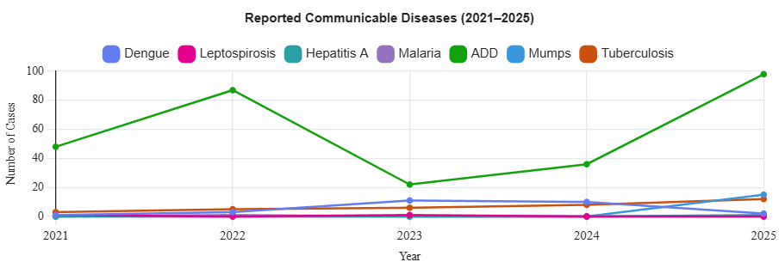

DENGUE
Dengue is a major seasonal vector-borne disease strongly associated with rainfall, water stagnation, and increased mosquito breeding during the monsoon period.

Peak: July–September
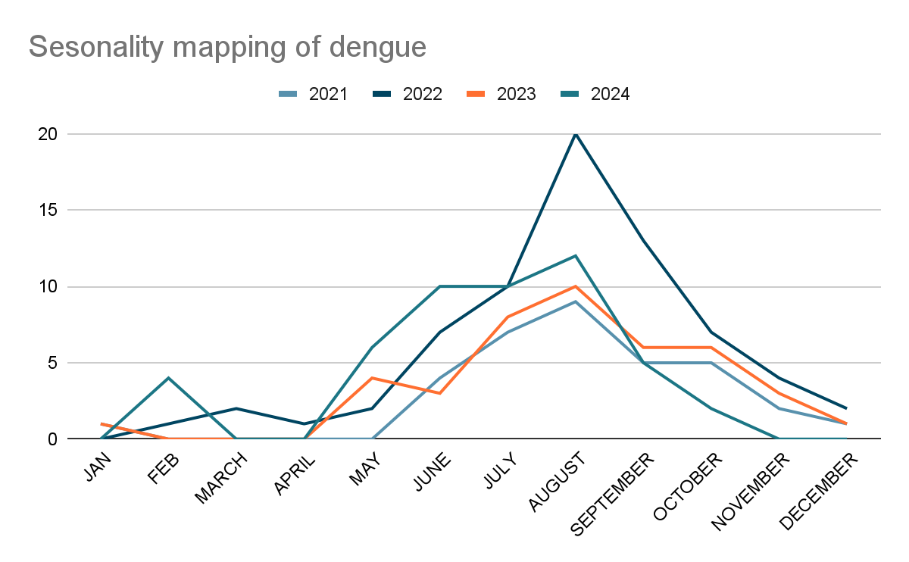

Dengue – Ward-wise Yearly Distribution (2021–2025)

Ward |  | Dengue – Ward-wise Yearly Distribution
 |  | 2021 | 2022 | 2023 | 2024 | 2025 | Total
1 |  | 0 | 0 | 1 | 1 | 1 | 3
2 |  | 0 | 0 | 0 | 0 | 0 | 0
3 |  | 0 | 1 | 2 | 1 | 0 | 4
4 |  | 0 | 0 | 1 | 1 | 0 | 2
5 |  | 1 | 0 | 0 | 0 | 0 | 1
6 |  | 0 | 0 | 1 | 2 | 0 | 3
7 |  | 0 | 0 | 1 | 0 | 0 | 1
8 |  | 0 | 1 | 0 | 0 | 0 | 1
9 |  | 0 | 0 | 1 | 1 | 0 | 2
10 |  | 0 | 0 | 1 | 0 | 0 | 1
11 |  | 0 | 0 | 2 | 2 | 0 | 4
12 |  | 0 | 1 | 0 | 0 | 1 | 2
13 |  | 0 | 0 | 0 | 1 | 0 | 1
14 |  | 0 | 0 | 0 | 0 | 0 | 0
15 |  | 0 | 0 | 1 | 1 | 0 | 2

LEPTOSPIROSIS
Leptospirosis cases are closely linked to monsoon rains, flooding, and occupational exposure, particularly in low-lying and waterlogged areas.
Peak:

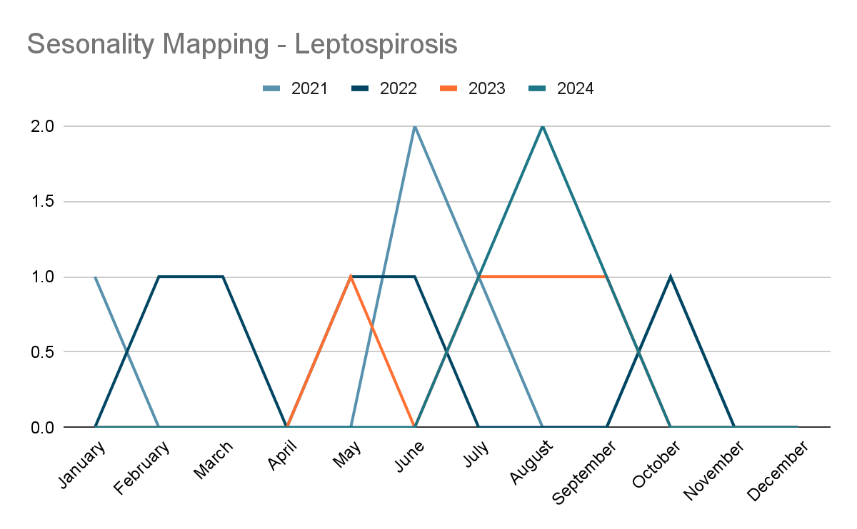

Leptospirosis – Ward-wise Yearly Distribution (2021–2025)

Ward | Leptospirosis – Ward-wise Yearly Distribution
 | 2021 | 2022 | 2023 | 2024 | 2025 | Total
1 | 0 | 0 | 0 | 0 | 0 | 0
2 | 0 | 0 | 0 | 0 | 0 | 0
3 | 0 | 0 | 0 | 0 | 0 | 0
4 | 0 | 0 | 0 | 0 | 0 | 0
5 | 0 | 0 | 0 | 0 | 0 | 0
6 | 0 | 0 | 0 | 0 | 0 | 0
7 | 0 | 0 | 0 | 0 | 0 | 0
8 | 1 | 0 | 0 | 0 | 0 | 1
9 | 0 | 0 | 0 | 0 | 0 | 0
10 | 0 | 0 | 0 | 0 | 0 | 0
11 | 0 | 0 | 0 | 0 | 0 | 0
12 | 0 | 0 | 0 | 0 | 0 | 0
13 | 0 | 0 | 0 | 0 | 0 | 0
14 | 0 | 0 | 1 | 0 | 0 | 1
15 | 0 | 0 | 0 | 0 | 0 | 0

VIRAL HEPATITIS - A
Hepatitis A cases are commonly associated with unsafe drinking water, food contamination, and breakdowns in sanitation, often presenting as clusters or outbreaks.
Peak:
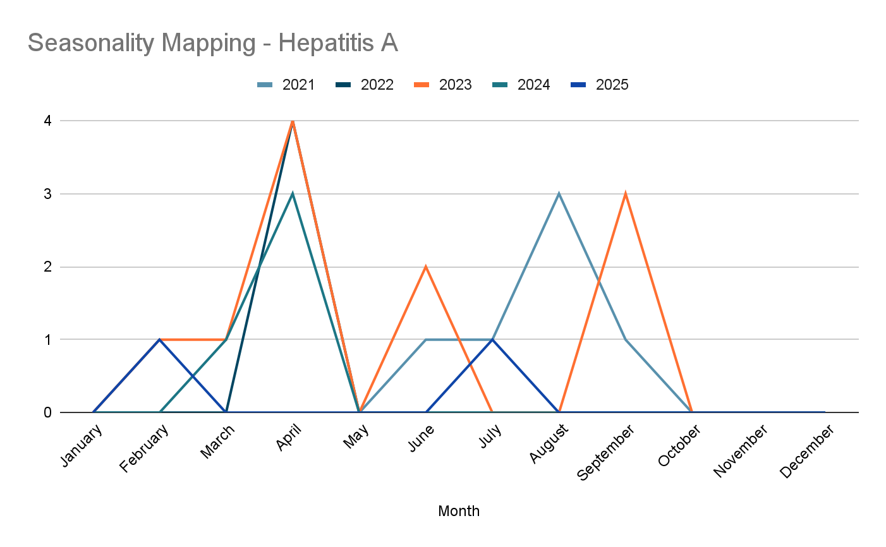

Hepatitis A – Ward-wise Yearly Distribution (2021–2025)

Ward | Hep A – Ward-wise Yearly Distribution
 | 2021 | 2022 | 2023 | 2024 | 2025 | Total
1 | 0 | 0 | 0 | 0 | 0 | 0
2 | 0 | 0 | 0 | 0 | 0 | 0
3 | 0 | 0 | 0 | 0 | 0 | 0
4 | 0 | 0 | 0 | 0 | 0 | 0
5 | 0 | 0 | 0 | 0 | 0 | 0
6 | 0 | 0 | 0 | 0 | 0 | 0
7 | 0 | 0 | 0 | 0 | 0 | 0
8 | 0 | 0 | 0 | 0 | 0 | 0
9 | 0 | 0 | 0 | 0 | 0 | 0
10 | 0 | 0 | 0 | 0 | 0 | 0
11 | 0 | 0 | 0 | 0 | 1 | 1
12 | 0 | 0 | 0 | 0 | 0 | 0
13 | 0 | 0 | 0 | 0 | 1 | 0
14 | 0 | 0 | 0 | 0 | 0 | 0
15 | 0 | 0 | 0 | 0 | 0 | 0

Outcome Based Trend Analysis- 2025
An approach for monitoring and analyzing the disease patterns based on the outcomes or impacts of specific interventions, policies, or public health measures and concerns. It shifts emphasis from merely tracking disease incidence to evaluating the effectiveness of prevention measures implemented for the disease. This type of analysis is crucial for understanding not only the spreadness of diseases but also how well the system is responding to them. This analysis evaluates the impact of various public health measures, determines whether these measures lead to reductions in disease prevalence, morbidity, mortality, or healthcare burden over time and this can be utilized modifying or improving existing health policies, resource allocation, and preparedness plans.

Sl. No. | Type of disease | Age group | Gender |  | Total no. of survival | Total no. of death | No. of cases received treatment
 |  |  | No. of Male | No. of Female
1 | Dengue | under 05 children | 0 | 0 | 0 | 0 | 0
2 |  | 5-19 years | 0 | 1 | 1 | 0 | 1
3 |  | 20-59 years | 12 | 9 | 21 | 0 | 21
4 |  | 60+ (Seniors) | 3 | 2 | 5 | 0 | 5
1 | Lepto | under 05 children | 0 | 0 | 0 | 0 | 0
2 |  | 5-19 years | 1 | 0 | 0 | 0 | 1
3 |  | 20-59 years | 1 | 0 | 0 | 0 | 1
4 |  | 60+ (Seniors) | 0 | 0 | 0 | 0 | 0
1 | VH-A | under 05 children | 0 | 0 | 0 | 0 | 0
2 |  | 5-19 years | 0 | 0 | 0 | 0 | 0
3 |  | 20-59 years | 1 | 0 | 1 | 0 | 1
4 |  | 60+ (Seniors) | 0 | 0 | 0 | 0 | 0

Integrated Disease Hotspot Map (2021–2025)
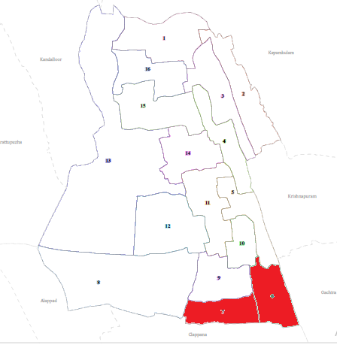

Transmission Trend- 2025
For effective management of public health issues, it is important to track the trend of disease transmission mode. It helps to identify the population or the place under high risk that can be used to predict outbreaks, and implement targeted interventions as fast as possible. Understanding these kind of trends enables authorities to allocate resources efficiently and change the strategies adequately based on the trend that follows.

Mode of Transmission | No. of cases | No. of Deaths
Vector Borne Diseases  (Dengue, Malaria, Chikungunya, Zika, JE, Filariasis, Scrub Typhus) | 2- DENGUE | 0
Water Borne Diseases  (ADD, Viral Hepatitis A & E, Typhoid, Cholera) | ADD-98 | 0
Airborne Diseases  (TB, COVID-19, Influenza (ILI / SARI), Measles , Chickenpox, Diphtheria, Pertussis, Mumps ) | TB- 9 MUMPS -15 CHICKENPOX -28 | 0
Blood Borne Diseases  (HIV/AIDS, Hepatitis B ,Hepatitis C , Syphilis) | NIL | 0
Food Borne Diseases  (Food Poisoning) | NIL | 0

\

Vector Borne Disease

Disease | No. of Cases | No. of Deaths
Dengue | 2 | 0
Malaria | 0 | 0
Chickengunea | 0 | 0
Yellow fever | 0 | 0

Water Borne Disease

Disease | No. of Cases | No. of Deaths
Cholera | 0 | 0
Typhoid | 0 | 0
Hep- A | 1 | 0
Dysentery | 0 | 0
Amoebiasis | 0 | 0
E- Coli infections | 0 | 0

Air Borne Disease

Disease | No. of Cases | No. of Deaths
Influenza | 0 | 0
H1N1 | 0 | 0
TB | 12 | 1
Chickenpox | 28 | 0
Measles | 0 | 0
Covid-19 | 0 | 0
Pertussis | 0 | 0
Mumps | 15 | 0

Blood Borne Disease

Disease | No. of Cases | No. of Deaths
AIDS | 0 | 0
Hep- B | 0 | 0
Hep- C | 0 | 0

Zoonotic Disease

Disease | No. of Cases | No. of Deaths
Rabies | 0 | 0
Leptospirosis | 0 | 0
Avian influenza | 0 | 0
West nile | 0 | 0
Anthrax | 0 | 0
Nipah | 0 | 0
Scrub Typhus | 0 | 0

Integrated Disease Hotspot Map (2021–2025)

Ward No | Dengue Total (2021-25) | Leptospirosis Total (2021-25) | Hepatitis A Total (2021-25) | Mumps (2021-25) | ADD (2021-25) | Total Cases
1 | 3 | 0 | 0 | 1 | 19 | 23
2 | 0 | 0 | 0 | 2 | 18 | 20
3 | 4 | 0 | 0 | 0 | 20 | 24
4 | 2 | 0 | 0 | 0 | 20 | 22
5 | 1 | 0 | 0 | 0 | 19 | 20
6 | 3 | 0 | 0 | 6 | 20 | 29
7 | 1 | 0 | 0 | 9 | 18 | 28
8 | 1 | 1 | 0 | 0 | 19 | 21
9 | 2 | 0 | 0 | 0 | 19 | 21
10 | 1 | 0 | 0 | 0 | 20 | 21
11 | 4 | 0 | 0 | 2 | 19 | 25
12 | 2 | 0 | 0 | 0 | 23 | 25
13 | 1 | 0 | 0 | 0 | 18 | 19
14 | 0 | 1 | 0 | 0 | 20
15 | 2 | 0 | 0 | 0 | 19

Preparedness and Response Protocol at LSG Level
This section describes the operational framework for the LSGI once a pandemic is declared. It explains how the LSGI and health system will move from routine data collection to active response, using a One Health approach.

Constitution of One Health Committee
The LSGD shall constitute a One Health Committee comprising the LSGI President, Medical Officers (Modern Medicine, AYUSH, and Veterinary), the Health Inspector, and the Veterinary Surgeon.

Objective: The One Health Committee coordinates human health, animal health, and environmental protection to prevent and control pandemics.

Sl No | Name | Designation | Department/Institution | Role in Committee | Contact Number
1 | AMBILI KALA | Panchayat President | LSGD | Chairperson | 9539676030
2 | DR ANOOPA M V | Medical Officer (PHC/CHC) | Health Dept | Member Secretary | 9497633650
3 | JINCY GEORGE | Veterinary Officer | Animal Husbandry | Member | 0476 2698979
4 | Dr. Krishnapriya | Epidemiologist | Health Dept | Member
5 | SHANAVAS H | Health Inspector/PHN | Health Dept | Surveillance | 9447087037
6 | GEETHA | ASHA Supervisor | Health Dept | Community link | 8756432087
7 | DHANYA | ICDS Supervisor | Social Welfare | Vulnerable groups | 9539158274
8 | SI | Police Station Officer | Police Dept | Law & order | 9497980276

Key Responsibilities:
- Review disease surveillance data (human + animal)
- Conduct ward-wise risk assessment and vulnerability mapping
- Approve quarantine/isolation centre locations
- Coordinate with district for resources (PPE, oxygen, ambulances)
- Periodically review health system surge capacity, including beds, oxygen, human resources, and ambulances.
- Approve and monitor risk communication and community engagement strategies, including rumour management.
- Ensure protection and service continuity for vulnerable groups (elderly, persons with disabilities, dialysis patients, coastal populations).
- Conduct quarterly mock drills
- Monitor equity measures for vulnerable groups

Meeting Schedule:
Quarterly (normal times) | Weekly (outbreak alert) | Daily (pandemic phase)

Pandemic Response Workforce
To ensure a coordinated and timely response during a pandemic, a dedicated Pandemic Response Workforce shall be constituted at the LSG level. The workforce will function under the overall supervision of the One Health Committee and in close coordination with the health authorities. Team-based deployment will enable efficient surveillance, case management, quarantine and isolation management, logistics support, and risk communication. Each team shall have a clearly designated team leader, defined roles, and an identified pool of personnel to allow rapid activation, rotation of duties, and continuity of services during prolonged emergencies.

Total Response Workforce Available: 300 persons

Team Name | Composition | Numbers Available | Key Responsibilities
Surveillance and Contact Tracing Team | HI, JHI, JPHN, ASHAs and Volunteers | HI: ___1_  JHI: _3__  JPHN_3___  ASHA: _27__  Volunteers: _57___ | Case detection, contact listing, home visits, reporting
Case Management Team | Doctors, Nurses, MLSP, Palliative Nurses | Doctors: __2_  Nurses: __2_  MLSP: __3_  Palliative: _1___ | Patient care & referral
Quarantine & Isolation Team | LSGD staff, Volunteers | LSGD staff__  Volunteers__57_ | Facility management
Logistics Team | LSGD staff, Storekeepers, Drivers | LSGD staff: ___  Drivers: __1_ | Supplies & transport [PPE, medicines, oxygen, transport, waste management]
Communication Team | Ward members, Kudumbashree, Youth clubs,  AWW workers | Ward members: ___15  Kudumbashree: __26_ | IEC, community meetings, countering misinformation

All teams shall be activated immediately upon outbreak alert or pandemic declaration and shall report daily to the LSG Incident Commander/Medical Officer, with consolidated reporting to the Block PHC. Duty rosters and alternate personnel shall be maintained to ensure uninterrupted services during staff shortages or prolonged response periods. Team composition and numbers may be revised based on the magnitude of the outbreak and availability of human resources.

Activities and Measures before and during Pandemic
Guidelines for active containment and monitoring.

PHASE 1 - Alert / Preparation

Activate One Health Committee
  - Immediately activate the One Health Committee at the LSG level. Convene an emergency meeting to review risk assessment, roles, and preparedness. Ensure coordination between Health, Veterinary, Agriculture, Local Self Government, and allied departments.
  - Prepare and circulate a contact directory of all committee members and emergency services.
  - Ensure documentation of decisions and action points with timelines.
  - Escalation hierarchy to be finalised (LSG to Institution to Block to District).

Surveillance and Reporting
Objective: To ensure early detection, timely reporting, and response to potential outbreaks through enhanced facility-, community-, and event-based surveillance
- Enhanced syndromic surveillance:
The LSGD shall initiate enhanced surveillance for priority syndromes and events such as:
  - Fever
  - Influenza-like illness (ILI)
  - Severe acute respiratory infection (SARI)
  - Unusual illness clusters (any unexpected increase in similar symptoms in a defined area or group)

Data sources for surveillance:
- Ward-wise household surveillance (through ASHAs/JPHNs/ward volunteers)
- Outpatient surveillance from all government facilities (PHC, FHC, CHC, GH, etc.)
- Private hospitals, clinics and labs
Event-based triggers (to be monitored and reported):
- School absenteeism above the usual pattern (to be monitored through the headmaster/PTA nodal person)
- Sudden increase in pharmacy sales of fever/cough/cold medicines
- Workplace illness clusters (multiple staff reporting similar symptoms within a short period)
- Zoonotic and animal health surveillance
- LSGD shall review reports of unusual animal deaths or suspected outbreaks in animals in coordination with the Veterinary Officer..

- Any unusual mortality in poultry, pigs, cattle, companion animals, or wild birds/mammals shall be notified within 24 hours to the Veterinary Officer and One Health Committee for joint investigation.

Reporting Mechanism:
All government and private health facilities, laboratories, and clinics within the LSGD shall report suspected and confirmed cases of notifiable diseases. Unusual clusters (schools, workplaces, neighborhoods, events, institutions) shall be reported within 24 hours of detection for verification and field investigation.​

Logistics and Stock Preparedness
  - Identify and empanel local vendors and define emergency procurement mechanisms in accordance with existing LSGD and Health Department norms.

  - Prepare and maintain an essential logistics checklist covering medical supplies, consumables, and support equipment.
  - Pre-identify secure storage locations for emergency stocks and ensure maintenance of stock registers with regular updating.
  - Finalise emergency transport arrangements, including availability of vehicles and identified drivers for rapid deployment during alerts.
  - Designate a Nodal Officer for Logistics to enable prompt decision-making, coordination, and communication during emergencies.
  - Conduct rapid stock verification and ensure availability of minimum buffer stock, including:
- PPE kits – 20 numbers
- Hand sanitizers – 5 litres
- Masks, gloves, disinfectants - adequate quantity
Identify critical gaps in logistics and immediately communicate requirements to the Block and District authorities for timely replenishment and support. Monitor expiry dates and stock rotation.

Identification of Quarantine and Isolation Facilities
  - Identify and list suitable buildings for quarantine and isolation (schools, hostels, community halls, etc.).
  - Categorize cases as per the severity and allocate to appropriate facilities (for instance, severe cases to class rooms, mild case to an assembly hall in case of a school).
  - Facility readiness checklist needed (beds, toilets, ventilation) etc.
  - Find alternate site if primary sites not available or not in use condition.
  - Identify facility managers and support staff
  - Prepare basic SOPs for:
    - Admission and discharge
    - Food, water, sanitation
    - Infection prevention and waste disposal
  - Ensure availability of basic amenities: water, sanitation, electricity, ventilation, and waste disposal. Prepare a rapid activation plan for these facilities if case numbers increase.

Risk Communication and Community Preparedness
  - Disseminate early warning messages on symptoms, preventive measures, and reporting mechanisms. Display IEC materials both in English and the local language in public places and ensure ward-level awareness.
  - Sensitize elected representatives and community leaders on preparedness measures.
  - Establish a rumour tracking and misinformation response mechanism to identify, verify, and promptly counter false or misleading information.
  - Engage trusted local persons (ward members, ASHA workers, religious leaders, teachers, community volunteers) to communicate official public health messages and reinforce correct practices.
  - Develop and deploy targeted IEC materials for:
    - Schools and educational institutions
    - Markets and commercial areas
    - Work sites and labour settings

  - Conduct community sensitization meetings at the ward level to promote preventive behaviors, address concerns, and strengthen community participation in preparedness and response.

Protection of Vulnerable Groups
Vulnerable populations require priority protection through targeted line-listing, service continuity, and delivery mechanisms.
- Prepare and regularly update line-lists of vulnerable populations, including:
  - Elderly persons living alone
  - Persons with disabilities
  - Pregnant women
  - Migrant workers
The detailed line-lists shall be maintained as Annexure ___ and updated periodically.

Clinical Dependency Mapping
Develop ward-wise dependency and vulnerability maps to identify households requiring regular support during emergencies. Ensure continuity of essential health services for vulnerable groups, including
- Dialysis services (facility mapping, transport arrangements, and scheduling)
- Continuity of treatment for TB, HIV, and other chronic conditions requiring uninterrupted medication
- Mental health and psychosocial support services
Establish delivery mechanisms for food, essential commodities, and medicines to vulnerable households through coordinated action involving ASHAs, JPHNs, Kudumbashree, volunteers, and local administration.

PHASE 2 - Active Response

Case Identification and Contact Tracing
Case detection and contact tracing activities will be carried out in coordination with the Health authorities, following disease-specific SOPs and IDSP guidelines.
Field Staff Involved
- Health Inspector (HI)
- Junior Health Inspector (JHI)
- Junior Public Health Nurse (JPHN)
- ASHAs and ASHA Supervisors
- Ward-level volunteers and Kudumbashree members (as required)

Screening Checkpoints
Screening checkpoints at high-traffic locations (transport hubs, markets, religious gatherings) for early detection of symptomatic travelers and crowd screening during outbreaks. Potential locations include bus stands, market entry points, and boat jetties, based on local context and risk assessment.
Screening activities will be carried out by trained personnel such as ASHAs, ward members, and volunteers, with support from Health Department staff. Necessary equipment including non-contact thermometers and appropriate PPE shall be ensured prior to activation.

Location | Type (Bus stand/Jetty/Market/Railway) | Staff Deployed (ASHAs/Volunteers) | Screening Method | Reporting authority
Bus stand | Transport hub | One JHI  One ASHA  One health Mentors | 1.Swab Collection.  2. Blood smears collection (RDT)  3.Thermal Scanners | Surveillance Nodal Officer in control room
Market entry | Market | One JHI  One ASHA  Male health volunteers | 1.Swab Collection.  2. Blood smears collection (RDT)  3.Thermal Scanners | Surveillance Nodal Officer in control room
Boat jetty | Water transport | One JHI  One ASHA  Male health volunteers | 1.Swab Collection.  2. Blood smears collection (RDT)  3.Thermal Scanners | Surveillance Nodal Officer in control room

Standard Screening Protocol
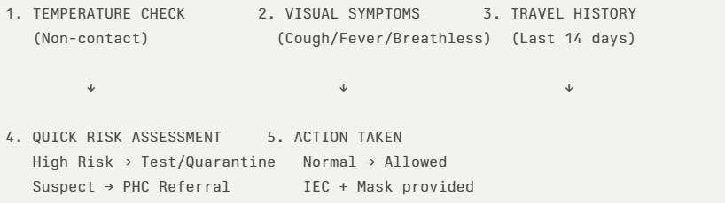
The screening protocol shall include temperature screening, observation for visible symptoms, and inquiry regarding recent travel or exposure history. Individuals identified as suspects during screening shall be immediately referred to the nearest PHC/FHC for further evaluation, testing, and appropriate action as per prevailing guidelines.

Pandemic Control Room
The Pandemic Control Room (PCR) serves as the central nerve center for real-time coordination, data aggregation, decision support, and communication during outbreaks. It consolidates information from all LSGD teams, health facilities and community sources to enable rapid response decisions.

Control Room Infrastructure and Location
Primary Location: Devikulangara LSGI (LSGD Office / PHC / Community Hall / Other: __)
Backup Location: Devikulangara phc (in case primary unavailable)

Health System Control Room Framework
The PCR is organized into seven functional pillars to ensure no aspect of the response is overlooked:

Rapid Response Team (RRT)
  - Provides immediate intervention during emergencies, clusters, and field alerts.​
  - Coordinates urgent actions such as case investigation, contact tracing, isolation, and inter-facility referrals.

Data Management & Analytics Team
  - Collects, validates, and manages key health system indicators (cases, tests, beds, HR, supplies).​
  - Analyzes data trends, generates projections, and supports evidence-based decision-making for local authorities.

Human Resource Deployment Team
  - Allocates healthcare staff efficiently based on workload and need
  - Ensures adequate and equitable workforce distribution across facilities

Laboratory Surveillance Team
  - Oversees diagnostic testing coordination, sample transport, and timely reporting of results.​
  - Monitors lab indicators (testing volume, positivity rate, turnaround time) for early detection of outbreaks

Vaccination Cell (If Required)
  - Plans and executes vaccination campaigns, including micro-planning and session scheduling.​
  - Tracks coverage, identifies gaps, and coordinates corrective actions with field teams and outreach services.

Infrastructure & Patient Occupancy Team
  - Monitors facility capacity, earmarked beds, oxygen and critical care resources across all linked facilities.​
  - Ensures optimal patient distribution and referral management using updated bed-status and resource data.

Policy Execution & Strategy Team
  - Implements health policies, SoPs, and government orders within the LSGD jurisdiction.​
  - Develops local strategies, reviews compliance, and recommends modifications based on field feedback and data.

Key Control Room Team
The Control Room Team coordinates all pandemic response activities within the LSGD and serves as the single command and communication hub during activation. It integrates information, field actions, logistics, and policy execution across all participating departments and health facilities.

Role | Name | Designation | Contact Number | Responsibility
In-charge/Nodal Officer | Dr.Anoopa | MO | 947633650 | Overall coordination, decision-making, and reporting to the District level.
Data Entry Operator | Mr. Syam | JHI | 7994003516 | Managing the line list, updating dashboards, and tracking testing results.
Communication Officer | Mr.Shanavas | HI | 9447087037 | Handling the public helpline, coordinating ambulance dispatch, and contact tracing calls.
Logistics Coordinator | Mr.Shanavas | HI | 9447087037 | Financial,transport handling
Technical Support (IT/Data) | Mrs.Pooja | JHI | 7994421447 | Data handiling

Key Points:
- The Control Room shall be staffed with a designated In-charge, data entry personnel, and communication staff with clearly defined roles and shift arrangements.
- It shall maintain updated records on daily monitoring indicators including new cases, persons under active quarantine, and hospital bed occupancy.
- All reports and situation updates shall be shared daily with the Block and District Surveillance Unit.
- The Control Room shall act as a single point of contact for coordination with response teams, health institutions, and other departments.
- Contact details of the Control Room shall be widely communicated to field staff and stakeholders during activation.

Daily Monitoring Indicators
To ensure timely decision-making and effective response, the following key indicators shall be monitored and updated on a daily basis by the Pandemic Control Room:

Epidemiological Indicators:
New cases reported today, Total active cases, Test Positivity Rate (TPR), Case Fatality Rate (CFR)
- Surveillance Indicators:
Persons under home quarantine, High-risk contacts identified, Fever, ILI, SARI or other symptoms (syndromic surges), Travellers (symptomatic or high-risk arrivals),Animal husbandry surveillance (zoonotic alerts, unusual animal deaths, poultry/bird flu signals), Mortality surveillance (excess deaths, unexplained fatalities, verbal autopsy reports)
- Logistics and Infrastructure Indicators:
Hospital / CFLTC beds occupied, Oxygen cylinders / concentrators available, Ambulances on standby
- Alert Findings
The following table outlines category-specific trigger points (red flags) from surveillance indicators and corresponding immediate actions for the Pandemic Control Room. These enable rapid response to alert findings like testing anomalies, positive cases exceeding thresholds, clusters, and WGS reports.

Category | Trigger Point (Red Flag) | Immediate Action
Clusters | Geographical or facility-based: 5+ cases linked to one location (office, school, street). | Declare a micro-containment zone; perimeter control and active case finding.
Testing | Sudden drop in testing volume / delay in reporting / unusual testing trends | Review the sample collection process, address lab bottlenecks, deploy additional testing teams, and notify the District Lab.
Lab | Test Positivity rate increases | Increase testing sites in that ward.
Hospital | >80% Oxygen bed occupancy | Activate backup/CFLTC beds.
Travel | Cluster of cases from a single flight/train or high-risk arrival group. | Trace all passengers in adjacent seats; implement mandatory institutional quarantine.
Animal | Mass poultry/wildlife death or unusual sickness | Notify Animal Husbandry, sample the area, and dispatch RRT for environmental sampling and zoonotic check.
Mortality | Sudden spike in home deaths or brought-in-dead (BID) cases | Audit the deaths and Active Case Search drive
Whole Genome Sequencing (WGS) | Detection of a Variant of Concern (VOC) or Variant of Interest (VOI) | Implement strict micro-containment; update clinical protocols to match variant severity.

Communication of Public Health Information
A Community Communication Hub shall be established to ensure timely, accurate, and consistent dissemination of information during a pandemic. The Hub will function under the coordination act as the nodal point for public communication, risk messaging, and community engagement. It will support dissemination of official advisories, promote preventive behaviors, address rumors and misinformation, and ensure that messages reach all sections of the population through trusted local channels and leaders.

Key communicators

Channel | Responsible Person | Contact
Ward-level announcements | RENADEV | 9847803282
Social media | Shyam | 7994003516
Local Cable TV/Radio | Shyam | 7994003516

- All messages disseminated through the Hub shall align with advisories issued by the Health Department and District authorities.
- Community leaders shall be sensitized to support behavior change, reduce stigma, and counter misinformation.
- Special efforts shall be made to reach vulnerable and hard-to-reach populations using locally appropriate communication methods.

Rumor Tracking: A designated volunteer will monitor local social media/WhatsApp groups daily to identify misinformation and issue official clarifications via the Communication Hub.

Coordination with District/State Authorities & Other Organisations
Effective coordination with Block, District, and State authorities is essential to ensure timely reporting, technical guidance, and uninterrupted supply of essential resources during a pandemic. The LSG shall establish clear communication channels, designate responsible officers, and adhere to prescribed reporting timelines to support coordinated public health action and efficient resource mobilisation.

Key Details:
- Nodal Officer for Reporting: Dr.Anoopa
- Contact Number: 9497633650

Reporting Schedule and Protocols:

To Whom | What to Report | Frequency | Nodal Person
Block PHC | Complete Situation Report (Cases, Quarantine, Beds, Screening, Deaths) | Daily | BMO
District IDSP Unit | Outbreaks/Clusters/Unusual Events (>5 cases same ward) | Within 24 hrs | DSO
Veterinary Officer | Animal health events/Zoonotic alerts | Daily | District Veterinary Officer
State Cell | Zoonotic cross-sector events | Daily | One health nodel officer

Supply Chain Coordination
The LSG shall coordinate closely with Block, District, and State authorities (KMSCL) to ensure uninterrupted availability of essential goods, medical supplies, and logistics during a pandemic. Supply requirements shall be assessed regularly based on case load and communicated promptly to the appropriate authorities for timely replenishment.
Key Points:
- Maintain updated contact details of District and Block nodal officers for health logistics, oxygen supply, ambulances, and essential medicines.
- Submit timely indent requests for PPE, testing kits, medicines, oxygen, and other critical supplies through prescribed channels.
- Monitor stock levels at LSGD facilities, quarantine/isolation centres, and field teams through daily stock registers and dispensing logs to prevent shortages.
- Coordinate with District authorities, Karunya/Neethi medical shops, and local purchase committees for funds allocation and emergency procurement.

- Ensure regular monitoring of dispensing registers at all facilities to track usage, expiry, and pilferage—shortages being a perennial issue requiring proactive weekly audits.

- Activate surge procurement protocols during high caseloads, leveraging local purchase powers under LSGD funds alongside state supplies.

Resource Inventory and Contacts
Resource Category | Source  (District/State/Private) | Contac t
PPE Kits/Masks/Gloves | KMSCL | 9895214070
PPE Kits/Masks/Gloves | Local Vendors | 9895214070
Oxygen  Cylinders/Concentrators | KMSCL | 9895214070  0479-2442806
Medicines/Antivirals | KMSCL | 9895214070
Medicines/Antivirals | Neethi Shops | 9656018108  8606908108
Test Kits (RTPCR/Rapid) | KMSCL | 9495757110

Collaboration with NGOs, PPP, and CSR
To augment government efforts during a pandemic, the LSG shall collaborate with NGOs, voluntary organisations, and private sector partners through public–private partnerships and Corporate Social Responsibility (CSR) initiatives, in coordination with District authorities.
Key Points:
- Engage NGOs and community-based organisations for community outreach, awareness, and support to vulnerable populations.
- Leverage CSR support for procurement of medical equipment, PPE, oxygen concentrators, food kits, and sanitation materials, as permitted.
- Ensure all collaborations align with government guidelines and are routed through approved administrative and financial procedures.
- Maintain transparency and documentation for all external support received and utilised.

Interdepartmental Coordination
Coordination among departments during a pandemic shall be ensured through regular review meetings convened by the LSGD President. These meetings will provide a structured platform for sharing situational updates, assessing resource availability, resolving operational gaps, and taking joint decisions to ensure a coordinated and timely response.

Department | Representative | Key Role | Contact
Health (PHC) | __MEDICAL OFFICER________ | Case management | __________
Veterinary | ________VETERINARY SURGEON __ | Animal surveillance | __________
ICDS | ___ICDS OFFICER_______ | Nutrition support | __________
Education | __________ | School coordination | __________
Police | __________ | Containment enforcement | __________
Fire/Rescue | __________ | Disinfection support | __________
Water Authority | __________ | Water supply | __________
LSGD Engineering | __________ | Quarantine infrastructure | __________

PHASE 3 - Surge Capacity
Phase 3 is activated when there is a rapid increase in cases, high test positivity rates, or when existing health facilities and quarantine arrangements approach saturation. The focus of this phase is to expand isolation capacity, augment clinical care services, and mobilise additional resources through district and state support mechanisms.

Conversion of Community Facilities
To manage increased case load, the LSGD shall activate additional isolation facilities by repurposing identified community infrastructure such as community halls, auditoriums, schools, hostels, or other suitable buildings.

Facility Type | No. of Buildings | Ward | Surge Capacity (Beds) | Nodal Person
Community Halls | 5 | Ward _11,4,10,12,14__ | _150__ beds/building (Total: ___) | HI
Schools (Closed) | 10 | Ward2,14,6,13,7___ | ___800 beds/building (Total: ___) | HI
Auditoriums | 5 | Ward 11,4,10,12,14___ | __300_ beds/building (Total: ___) | HI
Religious Halls | 1 | Ward __13_ | __20_ beds/building (Total: ___) | JHI

CONCLUSION
This Pandemic Preparedness Plan outlines a comprehensive, decentralised, and action-oriented framework for preparedness and response at the LSGD level. By adopting a One Health approach and strengthening coordination between the health system, local self-government institutions, veterinary services, and community networks, the LSGD aims to ensure early detection, rapid response, and effective containment of pandemics and public health emergencies.
The plan emphasises equity, community participation, and evidence-based decision-making to protect vulnerable populations and ensure uninterrupted access to essential services during crises. Regular updating, mock drills, and interdepartmental coordination will be critical to maintaining readiness and resilience.
This document shall serve as a living operational guide, to be activated during alerts and continuously improved based on evolving risks, lessons learnt, and guidance from higher authorities.

RECOMMENDATIONS

- It would be more effective that vulnerable populations and essential demographic infrastructure be systematically mapped at the ward level by each LSGD. This would enable precise identification of critical resources and vulnerability hotspots, thereby facilitating more targeted and timely response during emergency situations.
- Ward-level risk grading using the Hazard Risk Index can support prioritized allocation of response teams within LSGDs, reducing the likelihood of hazard spillover.
- Areas identified as high risk at wards of each LSGD, with higher reported mortality or lifelong morbidity, can be systematically reassessed using survival analysis to evaluate time-to-event outcomes and improve risk stratification.
- Hazard and risk projections should be modelled under the Representative Concentration Pathways (RCP 8.5) climate change scenario to evaluate future changes in hazard frequency and intensity, enabling scenario-based risk assessment and informed decision-making for long-term climate adaptation strategies.

MOCKDRILL SCENARIOS

Fire and safety workshop conducted.
Emergency medical care workshop conducted.

ANNEXURE

IMPORTANT PHONE NUMBERS

Phone numbers and particulars of persons responsible for providing guidance, assistance, and support for pandemic preparedness operations may be provided here in a manner that allows easy reference at a glance. The information recorded here could be exhibited elsewhere at the time of emergencies. LSG institutions shall give special attention to collect and record the above data of persons and institutions who/which are supposed to give technical and co-ordination support to reduce the impact of pandemic.

1.1. Details of grama panchayat/municipality/corporation wards
Sl.  No | Name of the ward | Ward number | Name of the ward  member | Contact number
1 | GOVINDAMUTTOM | I | E. Sreedevi | 9446616645
2 | VADAKKU KOCHUMURI | II | Sreedevi Sathyan | 9744806735
3 | KANIYAMURI | III | Dhanya Soman | 9605955453
4 | VADAKKE ANJILIMOOD | IV | Leena Raju | 9656202053
5 | THEKKEANJILIMOOD | V | Saleem Kalleli | 9847373380
6 | HIGHSCHOOL WARD | VI | Rekha | 9048567442
7 | SHAKTHIKULANGARA | VII | Bindhu T | 8606787182
8 | KDASSERIL | VIII | Arun | 9961610007
9 | KALEEKKASSERY | IX | Ambilikala T. | 9539676030
10 | THANAKULAM | X | Stalin Hentry | 9947334641
11 | DEVIKULANGARA | XI | Anju Thampi | 9605122924
12 | BANK WARD | XII | M.K Sajimon | 9496273921
13 | KUMBILISERIL | XIII | Chithra Soman | 9961070544
14 | KRISHI BHAVAN | XIV | K Remanan | 9747542890
15 | VARANAPPALLI | XV | U Sreejith | 9747617311
16 | TEMPLE WARD | XVI | Syam Sasi | 7034195050

1.2. Other important phone numbers of grama panchayat/municipality/corporation area
Sl. No. | Name | Contact number
1. | K C Venugopal | 9447016661
2. | Adv. U Prathibha | 9495465666
3. | Collector (head of District Disaster Management Authority) | 04772251720,9447129011
4. | Tahasildar | 0479 2472797  9447495007
5. | District Panchayat Secretary | 04772253836
6. | Block Panchayat Secretary | 8281040540

1.3. Important offices of grama panchayat/municipality/ corporation
Sl.No | Name of the office | Contact person | Contact number
1. | Village Office | VILLAGE OFFICER | 0479 2445700,8547611602
2. | Agriculture Office | AGRICULTURE OFFICER | 0479 2448866
3. | Animal Husbandry Office | VETIENARY SURGEON | 9446190527
4. | Police Station | SHO | 9497980276
5. | BSNL Office | SUB DIVISIONAL  OFFICER | 04792448200
6. | Block Office | SECRETARY | 8281040540
7. | KSEB Office | ASST .ENGINEER | 9496008624
8. | Fisheries Office | DEPUTY DIRECTOR | 9496007028
9. | Fire and Rescue | FIRE OFFICER | 04792442101
10. | Money Exchanges | MANAGER (FEDERAL BANK ) | 04792442604

1.4. Health Services

Sl. No | Name of the hospital/institution | Location | Phone number
1. | Government hospitals/PHC | FHC DEVIKULANGARA | 04762698686
2. | Private hospitals | VADAKKE ANJILIMOOD | 9747512277
3. | Clinical laboratories
4. | Chemist/pharmacy
5. | Blood donors | THE MODERN SPORTS &ARTS CLUB | 9947797190
6. | Other language experts (Bihari, Hindi, Bengali,  Asamees ………) | PUTHUPALLY VADAKKU | 9497342834

1.5. Veterinary Services

Sl.No | Name of the Clinic | Name of the  Surgeon/Doctor | Place/  location | Phone  number
1 | VETERINARY DISPENSARY | GINCY GEORGE | VADAKKE ANJILIMOOD | 94461990527
2 | VETERINARY SUB CENTRE | GINCY GEORGE | GOVINDAMUTTOM | 94461990527
3
 | Name of the shelter | Name of the Manager | Place/location | Phone  number
4. | CMS LP SCHOOL | HM | PUTHUPPALLY | 04792443068

1.6. Helpline numbers
Helpline | Phone number
Police | 100
Fire and Rescue | 101
Child Line | 1098
Crime stopper | 1091
Railway enquiry | 139
Ham Radio Operator | -
Chemical factories | -
Blood Banks | PARUMALA-04792312266
 | CHITRA HOSPITAL-04734252865
 | GOVT TD MEDICAL COLLEGE-04772282015
Ambulance Service | THQH KAYAMKULAM-04792447274
Mortuary service including mobile mortuaries | J J HOSPITAL 04792443196
 | THQH KAYAMKULAM- 04792447274

1.7. Public and Private Schools Contact details

S.No | Name of School | Phone number
1 | GOVT SRV LPS PUTHUPPALLY NORTH | 9496231610
2 | GOVT LPS PUTHUPPALLY | 9400879807
3 | GOVT UPS PUTHUPPALLY | 8547231548
4 | KNM GOVT UPS PUTHUPPALLY | 9747039858
5 | CHULOOR UPS PUTHUPPALLY | 9995654611
6 | CMS LP SCHOOL | 9747764807
7 | RVSM HS PRAYAR | 9446150722
8 | RVSM HSS PRAYAR | 8547714197
9 | CMS HS UTHUPPLLY | 9447431188
10 | S N PUBLIC SCHOOL | 9562934760

1.8. Public and Private Colleges Contact details

S.No | Name of college | Phone number
 | NIL

1.9. Anganwadi Contact Details

S.No | Name of Anganwadi | Phone number
1 | CHETTIMUNNAR | 9961376966
2 | CHETTIYAARKULAM | 9995306112
3 | SAKTHIKULANGARA | 9539641763
4 | THANAAKULAM | 8156817230
5 | PARAYANATHUMUKKU | 9605165733
6 | AALAMPALLIL | 9847277176
7 | SNEHAJALAKAM AW NO 7 | 7356787238
8 | KUTTIYILMUKKU | 9847455050
9 | THEKKEANJILIMOOD | 9747621168
10 | KRISHI BHAVAN | 9605645378
11 | VARANAPPALLIL | 9562956525
12 | THUMBILISSERIL | 9744749407
13 | KAREEL | 9961417984
14 | KRISHI BHAVAN WARD | 8137072491
15 | KANIYAMURI | 9605682540
16 | PANACHOOR | 9645878801
17 | CHOOLOOR SCHOOL | 9947972042
18 | AMBALAPPATTU | 7907439366
19 | DEVIKULANGARA | 9048203332

1.10. National and International organizations

S.No | Name of Organization | Phone number
1 | NIL | NIL

1.11. Details of Non-Governmental Organizations (NGOs)

S.No | Name of NGO | Phone number
1 | The Modern Sports & Arts Club | 9947797190
2 | Jaladara Arts & Sports Club | 8136945903
3 | Ashraya Charitable Trust | 9747157360
4 | Yuvajana Samathi, Anakkunnel | 8967542389
5 | Kalavedi & recreation Club | 9086675643

1.12. Information regarding resources

Means of transportation | Name of Owner | Phone Number
JCB | Kalesh | 8281300483
Crane | - | -
Heavy Trucks | K .Jayakumar | 9447349123
Tractor | - | -
Ambulances | - | -
Mobile mortuaries | - | -
Boats | - | -
Taxi service | Jasheer | 9447366206

